Meet the
Gene Machine

Teachers’ Resource Pack



This pack is also available online:

http://www.uwe.ac.uk/fas/graphicscience/projects/events/GMCPDresources/Teacher%20CPD%20Pack.doc

Meet the Gene Machine – Teachers’ Resource Pack

Contents

 | page
Introduction to the Resource Pack | 3
Activities | 4
Activity 1: Group Presentations: “Our Views on Genetic Testing” | 5
Instructions | 6
Teacher/Technician prep sheet | 9
Student Resources: Student Fact Sheets A-E | 10
Activity 2: Genetics in the Headlines | 15
Instructions | 16
Teacher/Technician prep sheet | 17
Student Resources: Examples of Genetics in the Headlines | 18
Activity 3: Genetic Testing, Discussion Continuum | 20
Instructions | 21
Teacher/Technician prep sheet | 23
Student Resources: Statement/Discussion cards | 24
Student Resources: Information Files | 25
Activity 4: Ballot Box - ‘Saviour Siblings’ | 27
Instructions | 28
Teacher/Technician prep sheet | 30
Student Resources: Background Information Sheet | 31
Student Resources: Student Resource Sheet | 32
Student Resources: Ballot Sheets | 33
Activity 5: The Link Game | 35
Instructions | 36
Teacher/Technician prep sheet | 37
Student Resources: Table of Definitions | 38
Activity 6: Role Play | 39
Instructions | 40
Teacher/Technician prep sheet | 41
Student Resources: Scenario card A | 42
Student Resources: Character Prompts for Scenario A | 43
Student Resources: Scenario card B | 44
Student Resources: Character Prompts for Scenario B | 45
Student Resources: Scenario card C | 46
Student Resources: Character Prompts for Scenario C | 47
Activity 7: Genetics Questionnaire | 48
Instructions | 49
Teacher/Technician prep sheet | 50
Student Resources: Questionnaire | 51
Activity 8: Fill in Cartoons | 52
Instructions | 53
Teacher/Technician prep sheet | 54
Student Resources: Cartoon 1 | 55
Student Resources: Cartoon 2 | 56
Student Resources: Cartoon 3 | 57
Student Resources: Cartoon 4 | 58
Tips for Organising Group Discussion | 59
Appendices | 63
Appendix 1: Meet the Gene Machine & The Curriculum | 64
Appendix 2: Glossary of Terms | 66

Meet the Gene Machine – Teachers’ Resource Pack

Introduction

This pack contains resources and activities to be used by teaching staff. The materials included in this pack will help teachers run effective classroom discussion/debate and brainstorming sessions which will allow their pupils to learn and discuss various boethics issues.

There are several approaches suggested in this training pack so that teaching staff, faced with a variety of pupil groups and their own preferred teaching styles, will be able to select and adapt the materials accordingly.

Appendix 11 goes into detail about how Meet the Gene Machine is relevant across many aspects of the curriculum, in science and also for Citizenship, PSHE, Drama and English. There is also a curriculum link with each activity. The materials provided in this pack are appropriate across a range of disciplines; there are valuable contributions to be made from Science, English and Humanities teachers, and we would recommend a coordinated approach, incorporating skills from these traditionally different areas of the curriculum.

The age range recommended is from late KS3 onwards, and teachers would need to adapt materials according to local factors such as reading age, prior experiences and whole school themes.

Before working through the materials in the classroom we would recommend, that you:

- Work with another colleague, bringing together for example Science and English.
- Work though all the suggested activities, making notes in the spaces provided.
- Identify the areas in the units that are the most appropriate and develop these for your classes.
- Note that you will need access to the Internet for some of the materials.

In August 2002, the programme of study for citizenship became statutory. This document, and the associated scheme of work, describes areas where links can be made to the exploration of contemporary issues in many subjects.
You may wish to use these materials to support current arrangements used in your school to enable pupils to meet the requirements of citizenship.

To inform the discussions, teachers and students will need access to background information on genetics and gene profiling. You are free to choose your own focus and to modify the materials to suit your lesson planning needs. For useful background information there is a PowerPoint slide show online: http://www.uwe.ac.uk/fas/graphicscience/projects/events/meetthegenemachine.htm You may use this purely for your information or for use during your lessons.

ACTIVITIES



ACTIVITY 1

Group Presentations: “Our Views on Genetic Testing”



ACTIVITY 1: – Group Presentations: “Our Views on Gene Testing”

Lesson objectives:
Curriculum Links:

Science
- Pupils learn to present information, develop an argument and draw a conclusion, using scientific language.
Citizenship
- Pupils develop skills of enquiry, communication, participation and responsible action and therefore becoming informed and interested citizens. This will be achieved through creating links between pupils’ learning in the classroom and activities that take place across the school, in the community and the wider world.
English:
- To learn to speak fluently and appropriately in different contexts, adapting talk for a range of purposes and audiences.
PSHE:
- Gain greater knowledge and understanding of spiritual, moral, social and cultural issues through increased moral reasoning, clarifying their opinions and attitudes in discussions with their peers and informed adults and considering the consequences of their decisions.

This activity is for teachers of General Studies, Science related subjects and also those involved in Citizenship discussions. Most appropriate for Science classes in Year 11 and Post 16 Biology, however it can be amended to suit younger pupils. This is a lesson plan that should extend into two 50 minute sessions. The purpose of these lessons is to de-mystify the question of genetic testing, screening and profiling. Much has been printed in papers and discussed in the media, but how much is accurate and reflects the true nature of the situation? The idea is for students to work in groups to research and generate a short PowerPoint presentation, summarising the ‘facts’ and putting forward views on the questions posed here. The pupils may also generate their own questions. Presentations are very useful learning tools and explaining something to another person is a great way of cementing one’s understanding of a topic.

How to run this session:

Lesson 1:

- Start with a group talk on genetic testing. As an introduction you can use a power point presentation on genetic testing and it’s implications, which can be found on the ‘Meet the Gene Machine’ website: www.uwe.ac.uk/fas/graphicscience/projects/events/GMCPDresources/CPD.ppt
(10 minutes)

- Following an introduction into genetic testing divide the class into groups (consisting of 5 students). If you feel it is appropriate and your pupils agree you can group them according to genetic characteristics (5 minutes):

  - Put their hands together, fingers interlocked. Those who have their left thumb uppermost form one group, those with the right thumb form the other.

  - Look at earlobes and divide group further into those who have attached or pendulous earlobes.

  - Divide the groups up according to whether they have straight or curly hair.

  - Try right handed and left handed

  - Eye colour (blue, Brown, green.)

  - Hair colour (brown, black, natural blonde, auburn,)

- Allocate the cards labelled A-E (pages 10-14 of this activity pack) to each group. These cards contain information about different aspects of gene testing.

- Ask all the A’s to go and sit at table 1, B’s to table 2 etc to form a number of ‘expert’ groups. In these groups, ‘experts’ work together on their chosen area, reading the material that they have been given, making notes about the important points, and checking understanding with others in the group. (Allow 15 minutes).

- After this ‘expert’ analysis of the information, they return to their original group to report back on their area of expertise. The pupils should summarise the main aspects behind genetic testing, using the information and knowledge gained from each expert. (15 minutes)

- Each group should now decide upon a question to focus on (allocated one of the suggested questions below). Ensure they each have a different issue to discuss as the aim is for the whole group to cover a range of issues. (5 minutes)

Suggested questions for groups to think about:

- Should consent be necessary for a genetic test to be done on a person?
- Often a genetic test shows that a person has a genetic condition for which there is no cure. How is the information given by a genetic test helpful to the person?
- Can the information someone gets from a genetic test cause discrimination for or against them?
- Who would you share your genetic information with, and why?
- Should samples of DNA, taken during a genetic test be kept, and why?

Lesson 2:

How to run the session:

- The pupils should re-form their groups and use the internet or other forms of media to search and collect information to provide an informed answer to the question they chose (15 minutes).

- They should then put a 5 minute presentation together, it can be a visual presentation such as a diagram or picture or just a short talk. (Stress that the information should be in their own words and that any quotations should be acknowledged) (15 minutes).

- The groups should now show their presentations to the rest of the class. Depending on how much time you have left, you may wish to leave the actual presentations for a third lesson (20 minutes).

- As an incentive each presentation could be assessed by the rest of the class, using agreed criteria discussed beforehand. Marks could be awarded for aspects such as sequencing of material, coverage of material, quality of preparation, delivery and ability to answer questions.

See overleaf for resources required and preparation guidelines for this activity.
(For use by teacher or technician)

ACTIVITY 1: –Preparation Guidelines and Resources

Group Presentations – “Our Views on Gene Testing”

Lesson 1

Preparation guidelines and resources:

- Prepare samples from the power point presentation on genetic testing found on the following website: www.uwe.ac.uk/fas/graphicscience/projects/events/meetthegenemachine.htm

- Copies of media headlines (page 18-19 of the activity pack). Either print a copy for each student or display the headlines on power point

- The class will be divided into groups of 5 and each group needs a copy of the Student Fact Sheets, labelled A-E (pages 10-14 of the activity pack)

- Photocopy each fact sheet on a separate piece of paper

- Each member of a group should be allocated 1 fact sheet

Lesson 2

Preparation guidelines and resources:

- Prepare flip charts and coloured pens for students that may want to use them

- Prepare Powerpoint facilities for the students who want to use power point

- Each group will need access to the internet or other relevant forms of media; there is a vast source of media coverage on genetic testing on the following sites:
  - http://www.bbc.co.uk/
  - http://www.geneletter.com/
  - http://bioethics-today.group.shef.ac.uk/
  - http://www.hgc.gov.uk/Client/news.asp
  - http://www.dnapolicy.org/

For use by teacher or technician, preparing the activity: Group Presentations, ‘Our views on Gene Testing’.

Student sheet A: What is genetic testing?

Genetic testing involves examining a person's DNA, by taking a sample of cells (from blood or, occasionally, from other body fluids or tissues). Genetic tests are usually done to check for changes in someone’s DNA that cause disease or disability. Some of these DNA changes can be inherited from our parents.

What types of testing exist?

Genetic tests are usually used to check if a person has a genetically inherited condition or to see what a person’s risk is of getting a genetic condition in the future. The different types of genetic tests are outlined below ...

Diagnostic ...
Tests used to confirm a diagnosis based on physical signs

Predictive ...
Tests used to find mutations that cause disease/disability later in life

Carrier Identification ...
Tests used by people with a family history of genetically inherited disease (Often used by couples when deciding to have children)

Prenatal ...
Tests used to check the DNA of a foetus when there is risk of having a child with mental or physical disabilities

Newborn Screening ...
Tests done once a baby is born to check if it has any genetic conditions

Forensic Testing ...
Tests that are used to identify an individual for legal purposes

Research Testing ...
Tests used to find unknown genes or to identify the function of a gene

RESOURCES FOR ACTIVITY 1: – Student Fact Sheet A

RESOURCES FOR ACTIVITY 1: – Student Fact Sheet B

Student sheet B: How do genetic tests work?

Once a person decides to do a genetic test, a medical geneticist, genetic counsellor or primary care doctor can order the test after getting the person’s consent....

Genetic tests are performed on a sample of blood, hair, skin, amniotic fluid (the fluid that surrounds a foetus during pregnancy), or other tissues...

For example, a medical procedure called a buccal smear uses a small brush or cotton swab to collect a sample of cells from the inside of the cheek...

The sample is sent to a laboratory where technicians look for specific changes in chromosomes, DNA, or proteins, depending on the disorder they are looking for...

The laboratory then reports the test results to the person's doctor or genetic counsellor.

RESOURCES FOR ACTIVITY 1: – Student Fact Sheet C

Student sheet C: How are the results of a genetic test understood?

The results of genetic tests are not always straightforward, which often makes it hard to understand and explain them. When interpreting test results, doctors look at a person’s medical history, family history, and the type of genetic test that was done...

A positive test result means that the laboratory found a change in a gene, chromosome, or protein of interest. Depending on the purpose of the test, this result may confirm a diagnosis, show that a person carries a genetic mutation, identify an increased risk of developing a disease in the future, or suggest a need for further testing. A positive test can not show how severe a disease is or when exactly it will appear...

A negative test result means that the laboratory did not find a dangerous copy of the gene, chromosome, or protein of interest. This result can show that a person is not affected by a particular disorder, is not a carrier of a specific genetic mutation, or does not have an increased risk of developing a certain disease. It is possible, however, that a test missed a disease-causing mutation because tests cannot find all of the genetic changes that can cause a particular disorder. More testing may be needed to confirm a negative result.

RESOURCES FOR ACTIVITY 1: – Student Fact Sheet D

Student sheet D: What are the benefits of gene testing?
People with a family history of genetic conditions worry about their own future as well as that of their children...

If a test shows a negative result...
When a test showing that a person’s DNA doesn’t have the genetic mutation that causes the disease/disorder it can be a big relief...
It also means they can have less frequent medical check ups.

If a test shows a positive result...
A test that shows that a person has a genetic condition can relieve their uncertainties and help them make informed decisions for their future...
For conditions that can be treated, a test can speed up the process of diagnosis and help treat the diseases early on or reduce its severity. For tests that predict a person’s risk of getting a disease in the future it can help encourage changes in lifestyle to reduce the risk.

RESOURCES FOR ACTIVITY 1: – Student Fact Sheet E

Student sheet E: What are the disadvantages of gene testing?

Most disadvantages are to do with the way the results of the test can change a person's life.

Psychological impact: The emotions roused by learning that you are likely to develop a disease can be very stressful. Many people in families with a history of a disease have already seen close relatives struggle. A study found that, after 3 to 6 weeks, women that were tested for specific cancers, and received test results showing that they are at risk, experienced persistent worries, depression, confusion and sleep disturbance...

Family relations: Unlike other medical tests, gene tests reveal information not only about us but also about our relatives. The decision to have a gene test can affect the entire family. It can also reveal family secrets involving paternity or adoption. If a baby tests positive for sickle-cell anaemia it means that both of his or her parents carry the mutation that causes it. Someone identified as carrying the gene may feel anger, while one who hasn’t inherited the condition may be overwhelmed by guilt because they avoided the disease...

Medical choices: Someone who finds out they have a gene that puts them at high risk of getting a specific cancer may start having different therapies, or regular check-ups, that are dangerous or not always effective...
Privacy: Our genes hold an encyclopedia of information about us and, indirectly, about our relatives. Who should be able to have this information? And how is the information kept private? Genetic test results are normally included in a person's medical records. And forensic test results are kept in a national gene bank. Safeguarding this information is never a guarantee.

ACTIVITY 2

Genetics in the Headlines



ACTIVITY 2: – Genetics in the Headlines

Curriculum Links:

Science
- How science and scientists work within society.
- Working individually and in groups.
- Communicating their ideas with clarity and precision.
- All pupils develop their ability to relate their understanding of science to their own and other people’s decisions about lifestyles, and to scientific and technological developments in society.
Citizenship
- The importance of a free press, and the media's role in society, including the internet, in providing information and affecting opinions.
- Researching a topical political, spiritual, moral, social or cultural issue, problem or event by analyzing information from different sources, including ICT-based sources.
- Expressing, justifying and defending orally and in writing a personal opinion about such issues, problems or events.
- Contributing to group and exploratory class discussions, and taking part in formal debates.the school, in the community and the wider world.
English:
- To learn to speak fluently and appropriately in different contexts, adapting talk for a range of purposes and audiences.
- Select, compare and synthesise information from different texts
- Evaluate how information is presented

Description/Lesson Objectives

This activity is for teachers of General Studies, Science related subjects and also those involved in Citizenship discussions. Most appropriate for Science classes in Year 11 and Post 16 Biology. Students study media headlines, which are used as an icebreaker to inform discussion and opinions about controversial issues. They then present their opinions to the class.

How to run this Session

Start with a group talk on genetic testing. For an introduction you can use a power point presentation on genetic testing and it’s implications, which can be found on the ‘Meet the Gene Machine’ website: www.uwe.ac.uk/fas/graphicscience/projects/events/GMCPDresources/CPD.ppt (10 minutes)

Divide the class up into groups of 4 or 5.

Give each group the genetics in the headlines sheet and a sheet of A2 sugar paper.

The groups discuss their understanding and views on the article, and summarise their ideas on the sheet, using the coloured pens (20 minutes).

Select two or three of the groups (number of groups selected depends on time available) to explain what they have discussed (20 minutes).

The remaining groups pin up their ‘posters’ for the rest to read during subsequent lessons.

ACTIVITY 2: –Preparation Guidelines and Resources

Genetics in the Headlines

Preparation Guidelines and Resources

- Print out enough copies of the newspaper headlines for the whole class (page 18 and 19 of the activity pack)

- Provide separate, blank A2 sugar paper for students to write on

- Provide coloured pens and sugar paper

- The class will be split into groups of 4 or 5 and each group will be given one headline. So, you can either:

  - Print each headline on a separate piece of A4

or

- print out the headlines on one sheet and cut out each headline


For use by teacher or technician, preparing the activity: Genetics in the Headlines.

RESOURCES FOR ACTIVITY 2: – Example Genetic headlines

Genetic Headlines in the News


The NHS is to play an important role in making sure that advances in genetic testing do not lead to a neglected underclass of "unwell and uninsurable" people, the health secretary, John Reid, announced. (The Guardian 24/06/03)

NHS TO SAFEGUARD AGAINST ‘GENETIC UNDERCLASS’


Secretly taking DNA samples to establish blood relationships or to obtain other highly personal information should be made a criminal offence, Britain's genetic watchdog said yesterday.
(BBC NEWS 30/01/04)

TAKING DNA BY STEALTH ‘SHOULD BE OUTLAWED’
The US equal employment opportunities commissioner, Paul Miller, said there needs to be more regulations to safeguard workers rights. Hundreds of people have already lost their jobs or insurance protection because of advances in genetic screening. (The Guardian 22/05/02)

GENETIC TEST RISK CREATING A NEW UNDERCLASS
The results of tests for genetic diseases should be made available to insurance firms, say doctors. Writing in the Lancet medical journal, the University of East Anglia experts say it is unlikely the findings would be misused to treat customers unfairly.
(The Guardian 28/09/00)

INSURERS ‘SHOULD SEE GENE TESTS’

A change in the law that allows police to keep DNA samples from people who are arrested and later cleared has led to nearly 8,000 matches of unknown suspects. Previously, such records would have been destroyed. The matches include 96 in murder cases, 50 in attempted murders and 116 in rapes. (Daily Telegraph 28/11/05)

RETAINED DNA POINTS TO 8,000 CRIME SUSPECTS

With the recent arrival of bar-coding babies, where babies are given an electronic barcode, how close are we to more extreme plans like genetic screening of all babies at birth?
(Cambridge Genetics Knowledge Park 01/06/04)
BARCODE BABIES: PROSPECTS FOR GENETIC PROFILING

RESOURCES FOR ACTIVITY 2: – Example Genetic headlines

Genetic Headlines in the News Continued…

Using new DNA technology has allowed a team of scientists to study DNA differences in tumour cells in comparison to normal cells. This might help them predict which patients would respond better to specific types of treatment.
(Medical News Today 02/06/03)
GENETIC PROFILING TO PREDICT BREAST CANCER PATIENTS
Proposal for a national scheme to take DNA profiles of every baby in the UK have been rejected by genetics experts. The Human Genetics Commission (HGC) and the National Screening Committee had been asked to explore the pros and cons of profiling all babies.
(BBC News/Health 31/03/05)
DNA PROFILING OF BABIES REJECTED

ACTIVITY 3

Genetic Testing, Discussion Continuum

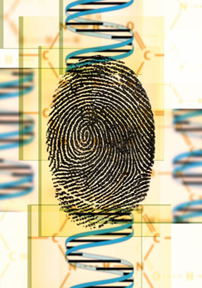

ACTIVITY 3: – Genetic Testing, Discussion Continuum

Description/Lesson Objectives
Curriculum Links:

Science
- How science and scientists work within society.
- Working individually and in groups.
- Communicating their ideas with clarity and precision.
- All pupils develop their ability to relate their understanding of science to their own and others’ decisions about lifestyles, and to scientific and technological developments in society.
Drama:
- Use different ways to convey action, character, atmosphere and tension
Citizenship
- Researching a topical political, spiritual, moral, social or cultural issue, problem or event by analyzing information from different sources, including ICT-based sources.
- Expressing, justifying and defending orally and in writing a personal opinion about such issues, problems or events.
- Contributing to group and exploratory class discussions, and taking part in formal debates.
PSHE:
- Gain greater knowledge and understanding of spiritual, moral, social and cultural issues through increased moral reasoning, clarifying their opinions and attitudes in discussions with their peers and informed adults and considering the consequences of their decisions.

This is a very flexible resource that could be used as part of wider work on the topic or as a lesson in its self. It is suitable for KS4 and post 16 students. This activity provides the opportunity to investigate genetic disorders and asks the students to consider a number of statements and situations concerning the social and ethical issues surrounding genetic testing. The aim is to discuss the issues raised by each statement and agree where each card should go on the scale between ‘agree’ and ‘disagree’. Larger groups could use the resource to have a free discussion on the topic, based on a ‘continuum line’ where they hear the statement, and stand at or near the opinion card, according to how they feel.

How to run this Session

- Stick the posters Agree and Disagree at opposite sides of the room

- Hand out the statement cards (page 24) and ask the students to read and think about them.

- Hand out the information files (page 25) so that they can check them for further information, such as the definition of terms.

- Ask a student in turn to read out a statement (5 minutes)

- Ask each person to stand in an area of the room according to how deeply they agree or disagree with the statement i.e. those who strongly agree will stand next to the agree card, those who strongly disagree will stand next to the ‘disagree’ poster and those who are unsure/agree to an extent will stand somewhere in the middle. (5 minutes)

- Ask some of the students to explain why they are standing where they are (5-10 minutes).

- Repeat this exercise for all of the statements

(N.B Refer to the information files on pages 25 and 26 for further detail on conditions mentioned in the statements).

See overleaf for resources required and preparation guidelines for this activity.
(For use by teacher or technician)

ACTIVITY 3: – Preparation Guidelines and Resources

Genetic Testing, Discussion Continuum

Preparation Guidelines and Resources



- Photocopy the 12 discussion/statement cards (page 24). You will need to copy enough to allocate one to every student.

- Photocopy the Information files (page 25). You will need to copy enough to allocate one to every student.
- Create large posters saying ‘Agree’ and ‘Disagree’ to stick at each end of the classroom.
For use by teacher or technician, preparing the activity: Genetic Testing, Discussion Continuum.

RESOURCES FOR ACTIVITY 3: – Discussion/Statement Cards

Genetic Testing – Discussion Continuum

Genetic testing and counselling should be free on the NHS, even if it costs the taxpayer more money. | All airline pilots should be tested for Familial hypercholesterolemia (FHC). This will improve passenger safety.  
People who carry the genes for terrible diseases like Huntingdon’s should not be allowed to have children. They should adopt instead. | My first child has Sanfilippo syndrome. When I get pregnant again I should be able to have prenatal testing for the disease.
Genetic testing kits for common diseases like cystic fibrosis should be available over the counter at chemists. | My wife and I have achondroplasia. We should be able to use IVF techniques to select a child who has achondroplasia too.
I know that I am a carrier of Duchenne muscular dystrophy. I should be able to use IVF techniques to make sure that my next baby is a girl. | Pre-implantation and prenatal genetic testing should be banned. You should just accept and love children as they are.
Mortgage and loan companies should have access to your genetic records - they don’t want to lend money to someone who might get sick or die. | I have Familial hypercholesterolemia (FHC) and there is a chance that my children will have too. I should be able to get them tested so that I can change their diets if necessary.
All newborn baby boys should be tested for Duchenne muscular dystrophy. That way parents would be informed before they have any more children.   | I am 15 and my Granddad has Huntington’s disease. My dad doesn’t want me to be tested but I do. I should be able to make the choice for myself.

RESOURCES FOR ACTIVITY 3: – Information Files

Genetic Testing – Discussion Continuum
Information File

Familial hypercolesterolaemia (FHC)

(Dominant)
Results in abnormally high blood cholesterol levels and hence an increased risk of heart disease. The mean age of onset of heart disease is 40 for male sufferers; 50-55 for female. This can be treated with drugs and a special diet. 1 in 500 of the population suffers with this condition.

Possibility of genetic testing:

Diagnosis can be made either by measuring blood cholesterol levels or by genetic testing.
Information File

Cystic Fibrosis (CF)

(Recessive)
Causes thick salty mucus to build up in the pancreas, lungs and bowel. Life expectancy depends on the severity of symptoms, but the average is 25-30yrs. There are a variety of treatments available for the symptoms but no cure. 1 in 25 people in Northern Europe carry the CF gene.

Possibility of genetic testing:
Some health authorities use genetic testing to screen all newborn babies for CF. Mouth swab tests are available for people who have an affected relative. It is also possible to carry out pre-natal testing.
Information File

Huntington’s Disease

(Dominant)
Affects the central nervous system. It causes increasing coordination and memory problems, mood changes and eventually death. Symptoms usually start around 30 – 50 yrs old but this is highly variable. An affected parent has a 50% chance of having an affected child.

Possibility of genetic testing:
Genetic tests are available - they will tell you if you have the gene, but will not give an indication of the age at which you will develop symptoms. Prenatal testing is also possible.
Information File

Duchenne muscular dystrophy (DMD)

(Recessive – but is X linked)
Causes muscular weakness. Symptoms start between ages 1and 3, sufferers are normally wheelchair bound by 12 and life expectancy is around 20yrs.
X-linkage means that females can be carriers, but males with the faulty gene always display symptoms.

Possibility of genetic testing:
Boys can be tested for DMD in two ways. The first is analysis of the levels of
creatine kinase in the blood. The second is a genetic test. It is also possible to carry out a prenatal test for the sex of subsequent children.

RESOURCES FOR ACTIVITY 3: – Information Files

Genetic Testing – Discussion Continuum Continued…
Information File

Achondroplasia

(Dominant, caused by mutant gene)
Also known as short -limbed dwarfism. Individuals with heterozygous achondroplasia have normal IQ and lifespan and an average adult height of four foot. Homozygous individuals however will be stillborn. Over 80% have no history of the disorder in the family - there has been a spontaneous new mutation. An affected parent has a 50% chance of having an affected child.

Possibility of genetic testing:
Achondroplasia can be detected in the womb using ultrasound. There is a DNA test for this condition.
Information File

Sanfillipo Syndrome

(Recessive)
Results in the build up of waste in cells, causing cell damage. Progressive mental deterioration occurs between 5 and 10yrs, children become hyperactive and disruptive, movement and speech are then lost and death occurs in the mid-teens.

Possibility of genetic testing:
Sanfilippo syndrome is so rare that parents tend to find that they are carriers only when they have a child who is affected. However, for subsequent children, they can opt to have chorionic villus sampling during pregnancy to see if the foetus is affected.

ACTIVITY 4

Ballot Box: ‘Saviour Siblings’



ACTIVITY 4: – Ballot Box: Saviour Siblings

Curriculum Links:

Science
- How science and scientists work within society.
- Working individually and in groups.
- Communicating their ideas with clarity and precision.
- All pupils develop their ability to relate their understanding of science to their own and others’ decisions about lifestyles, and to scientific and technological developments in society.
- Students look at the ethical considerations associated with advances in genetic modification and discussing the implication so the Human Genome Project
- How and why people find out about their genes and what decisions people make with the information.
Citizenship
- Researching a topical political, spiritual, moral, social or cultural issue, problem or event by analyzing information from different sources, including ICT-based sources.
- Expressing, justifying and defending orally and in writing a personal opinion about such issues, problems or events.
- Contributing to group and exploratory class discussions, and taking part in formal debates.
PSHE:
- Gain greater knowledge and understanding of spiritual, moral, social and cultural issues through increased moral reasoning, clarifying their opinions and attitudes in discussions with their peers and informed adults and considering the consequences of their decisions.

Description/Lesson Objectives

KS4/5 lesson plan for teachers of General Studies, Science related subjects and also those involved in Citizenship discussions. Children work together to put their opinions in the ‘Ballot Box’. We have chosen the topic ‘Saviour Siblings’ but you may want to use a topic and gather relevant articles of your own choosing. You may wish to start the lesson with a video clip of a recent, relevant news story.

How to run this session:

- Split the students into groups of three or four.

- Hand out the ‘Saviour Siblings’ resource sheet (page 32) or provide your pupils with an article you find more appropriate or more relevant.

- If you feel they need further information on the subject, hand out copies of the ‘background information sheet’ (page 31).

- Get the students to read the article then discuss the questions in their groups at the bottom of the sheet (20 minutes).

- Cut out the saviour siblings ballot sheets (feel free to add your own) and hand them to each group (page 33-34).

- Instruct them to answer the questions on the sheet. (Each student should have a different question to answer from the rest of their group).

- When they have answered their questions get them to fold the paper and pop it in the ballot box

- Pull out answers at random and use them as a means for stimulating discussion of their opinions. (20 minutes). You may wish to put these answers on the whiteboard or stick them to a wall or flipchart.

- Ask them to consider:

  - What conclusions do they draw from hearing what various people have read?

  - Does everyone have a clear idea about the topic?

  - What differences are there amongst people?

  - Has it changed their opinions?

See overleaf for resources required and preparation guidelines for this activity.
(For use by teacher or technician)

ACTIVITY 4: –Preparation Guidelines and Resources

Ballot Box: ‘Saviour Siblings’

Resources and preparation guidelines:

- Find or make a suitable box to use as the ‘ballot box’ for the students to put their answers in.

- Cut out the saviour sibling ballot sheets on pages 33-34 (enough for at least one sheet for every student in the class: not all the same questions, at least 4 different options)

- The class will be split up into groups of 3 or 4: photocopy enough of the Saviour Siblings Resource Sheet (page 32) for at least one sheet per group.

- Photocopy the background information sheet (page 31). (You will need enough for at least one per group).


For use by teacher or technician, preparing the activity: Ballot Box (Saviour Siblings).

‘SAVIOUR SIBLINGS’
RESOURCES FOR ACTIVITY 4: – Background Information Sheet

Ballot Box – Saviour Siblings

Background Information:

‘Saviour Siblings’

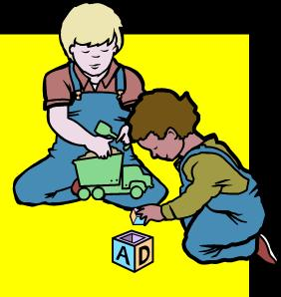
What Is A Saviour Sibling?

A "saviour sibling" is a brother or sister capable of donating life-saving tissue (e.g: blood, bone marrow or stem cells) to an existing child who is ill. A saviour sibling has the same type of tissue and is genetically very similar to his/her ill sibling.

The way it works:

- A woman’s eggs are fertilized with a man’s sperm in the lab
- Embryos are produced
- One or two cells are taken from an embryo when it is about three days old and genetic and tissue typing tests are run
- When an embryo is found that has the same type of tissue and similar genetics as the sick sibling, it is implanted in the mother’s womb
- Once the baby is born, stem cells are removed from the umbilical cord and stored for four to six months when a transplant to the sick child can take place.

What Is Thalassaemia?

It is a genetic condition that affects red blood cells, people with Thalassemia have very vulnerable red blood cells that die easily, in order to cope with the disease regular blood transfusions are needed.

RESOURCES FOR ACTIVITY 4: – Resource Sheet for Students

SAVIOUR SIBLINGS IN THE NEWS

1.  - Fertility regulators in the UK rule that families can pre-select embryos which could potentially save ill siblings.  (July 2004, New Scientist)  - The Human Fertilisation and Embryology Authority (HFEA) gave permission to a family from Leeds, the Hashmis, to create a donor sibling for their son who had the genetic blood disease thalassaemia.  2.     - The House of Lords is told that the Hashmis should never have been allowed to try to create a ‘designer baby’.  - Raj and Shahan Hashmi spark a fierce ethical debate over their permission to select an embryo whose tissue matched that of their six-year-old son, Zain.  - A campaign group called Comment on Reproductive Ethics (Core), seeks to ban the practice of tissue typing to help siblings.  (March 2005, The Scotsman) | 3.    - If Core wins its appeal, the Hashmis and dozen of other families will have to abandon their attempts to have a saviour sibling in Britain.  - Mrs Hashmi has had six attempts to have a saviour sibling, resulting in five miscarriages and one occasion where none of the embryos was a close enough match. Mrs. Hashmi said yesterday she knew of more than 100 families who were hoping to have the treatment.  (March 2005 The Guardian)  4.   - The Law Lords uphold the earlier court decision that the HFEA were right to allow the Hashmi family to select embryos that would match their son.  (April 2005, Public Health Genetics Unit)  5.  - Children created as so-called ‘saviour siblings’ to aid a sick brother or sister must be monitored to ensure their well-being, experts suggest.  (January 2006, BBC NEWS)

'SAVIOUR SIBLING' BABIES GET GREEN LIGHT
‘LORDS TO RULE ON SAVIOUR SIBLINGS’
‘LAW LORDS BACK SAVIOUR SIBLING RULING’
Instructions for the student:

- Form groups of three or four
- Read the short articles above.
- Discuss these questions:
  - What do you think about having saviour siblings?
  - Is it ok to create a child for a specific purpose? Why/why not?
  - What future effects (good and bad) do you think this technology could have (e.g on treating illnesses, on people’s reproductive choice, on the relationship between siblings etc)?
- When you have discussed the above questions you will be given question cards.
- Await further instructions from your teacher.
‘SAVIOUR SIBLING’ EMBRYO BATTLE
‘CONCERN OVER ‘SPARE PART’ BABIES’

RESOURCES FOR ACTIVITY 4: – Ballot Sheets for Students

Ballot Box – Saviour Siblings

 BALLOT SHEET 

If my parents told me that I was a saviour sibling I would feel…

BALLOT SHEET

If my parents told me that my brother/sister was a saviour sibling I would feel…

BALLOT SHEET

If I was a saviour sibling I would/would not want to know because…

BALLOT SHEET

If I was the parent of a saviour baby I would/would not tell them they were a saviour sibling because…

RESOURCES FOR ACTIVITY 4: – Ballot Sheets for Students

Ballot Box – Saviour Siblings

BALLOT SHEET

If I chose to have a saviour baby, other people would think that…

BALLOT SHEET

If I wanted to have a saviour baby I would ask my doctor about …

BALLOT SHEET

If I had a child with a disease that could be helped by creating a saviour sibling, I would/would not create one because…

BALLOT SHEET

If a friend/family member was considering creating a saviour sibling, I would advise them…

ACTIVITY 5

The Link Game
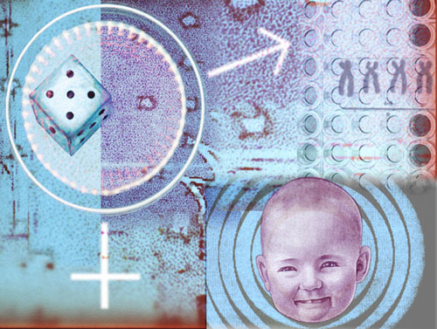

ACTIVITY 5: – The Link Game

Description/Lesson Objectives:
Curriculum Links:

Science
- Working individually and in groups.
- Communicating their ideas with clarity and precision.
- All pupils develop their ability to relate their understanding of science to their own and others’ decisions about lifestyles, and to scientific and technological developments in society.
- How and why people find out about their genes and what decisions people make with the information.
- Understanding how knowledge of genes is used to prevent disease.

This activity is appropriate for science classes and can be adapted to your own lesson plan. It is a short and easy activity to allow pupils to become accustomed with scientific and genetics terms and to learn to distinguish the terms and their definitions together.

NOTE: The timing for this activity depends on whether the pupils’ have previously encountered the terms.

How to run this activity:

- Select terms and definitions you would like to use and type them into the template overleaf. Type in the word, then in the next box on the right, BELOW this word, put in the definition. Continue this, alternating the word with definition, until the last word. Here the definition is written into the left hand box of the first question to complete the loop.

- Cut the cards up and give one to each pupil in the class (so that they each have both a word and a definition that do not go with one another).

- Get one pupil to stand up and read out their word

- Get the person who thinks they have the definition for that word to read it out (teacher adjudicates... they should have a copy of the answers!)

- If they have the correct definition they stand with the first pupil and read out their word.

- The person with the correct definition stands with them and the game continues until all the words are defined and hopefully a loop has been formed.

- To add a sense of competition, the game can be timed and then repeated next lesson perhaps, so that the group can try to beat their own record.

ACTIVITY 5: – Preparation Guidelines and Resources

The Link Game

Resources and preparation guidelines:

- Print out the table of definitions and answers (overleaf, page 38) on coloured card.
N.B. If you want to add to/change the table, check the glossary of terms in the appendices and add your own definitions before printing.

- Cut along the dotted lines so that each card shows both a term and a definition, which do not go together.

- You will need enough cards for each student so if you need to add to the table remember that the order is important:

- Type in the word, then in the box on the right, BELOW this word, type in the definition.
- Continue this, alternating the word with definition, until the last word. Here the definition is written into the left hand box of the first question to complete the loop.

e.g.

1st term | Final definition
2nd term | 1st definition
Final term | 2nd definition

For use by teacher or technician, preparing the activity: ‘The Link Game’.

RESOURCES FOR ACTIVITY 5: – Example Table of Definitions

The Link Game

Carrier: | An international research effort aimed at identifying and ordering every base in the human genome.
Cystic fibrosis: | A person who has a recessive mutated gene, together with its normal allele. Carriers do not usually develop disease but can pass the mutated gene on to their children.
Gene testing: | An inherited disease in which a thick mucus clogs the lungs and blocks the ducts of the pancreas
Newborn screening: | Examining a sample of blood or other body fluid or tissue for biochemical, chromosomal, or genetic markers that indicate the presence or absence of genetic disease.
Human Genome Project: | Examining blood samples from a newborn infant to detect disease-related abnormalities or deficiencies in gene products.

ACTIVITY 6

Role Play



ACTIVITY 6: – Role Play

Curriculum Links:

Science
Pupils should be taught the applications and implications of science:
- About the use of contemporary scientific and technological developments and their benefits, drawbacks and risks.
- To consider how and why decisions about science and technology are made, including those that raise ethical issues, and about the social, economic and environmental effects of such decisions
- How uncertainties in scientific knowledge and scientific ideas change over time and about the role of the scientific community in validating these changes.
English:
- To speak fluently and appropriately in different contexts, adapting their talk for a range of purposes and audiences, including the more formal.
Drama
- Use different ways to convey action, character, atmosphere and tension
PSHE:
- Gain greater knowledge and understanding of spiritual, moral, social and cultural issues through increased moral reasoning, clarifying their opinions and attitudes in discussions with their peers and informed adults and considering the consequences of their decisions.
Citizenship:
- Research a topical political, spiritual, moral, social or cultural issue, problem or event.
- Express, justify and defend orally and in writing a personal opinion about such issues.
- Contribute to group and exploratory class discussions, and take part in formal debate.

Description/Lesson Objectives

This is a KS4/5 lesson plan for teachers of General Studies, Science related subjects and also those involved in Citizenship discussions. Allow a full lesson for this, which will include time for feedback of group ideas. It involves working in groups to undertake role plays of different scenarios, in order to explore the differing opinions that exist as to the advantages and disadvantages of genetic profiling.

How to run this session:

- Split the students into groups of 5

- Each group should be allocated a scenario card. We have created three examples for you, (pages 42-47), along with character prompts for the different roles. You may wish to add some of your own.

- One member of the group should act as scribe and reporter. They will take notes throughout the session.

- The others should each be allocated a role from the scenario and perform the role play within their groups. (They can refer to the prompts as a point of reference). (15 minutes).

- The scribe for each group should then report back to the class on what points the group expressed during the role play (20 minutes).
ACTIVITY 6: – Preparation Guidelines and Resources

Role Play

Resources and preparation guidelines:

- Print out the Scenario cards, (pages 42, 44 and 46), along with the accompanying character prompts, (pages 43, 45 and 47), on A4 card.

- You will need enough for 1 card per group (they will be split into groups of 5).

- Provide pen and paper to each group, for the observer to write their notes on.

- You may wish to cut out character prompts so that they can be given to the person playing that role.

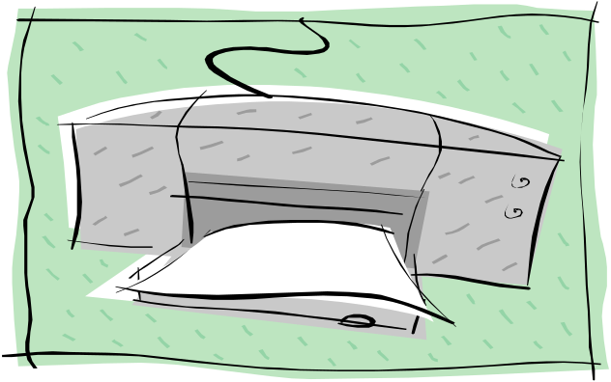
For use by teacher or technician, preparing the activity: ‘Role Play’.

RESOURCES FOR ACTIVITY 6: – Scenario Card A

Role Play

SCENARIO A

Instructions:

- Read the scenario below and assign one of the roles below to each person in the group (one of you should act as scribe, while the rest take part in the role play).
- You may use the character prompts to familiarise yourself with your role before the role play.
- Perform the role play in your groups, remember to stay in character, raising the points you think that character would raise.
- The scribe should take notes on the points raised, throughout the role play so that they can feedback to the rest of the class.

Scenario:

You are members of a panel appointed by your city council to discuss whether or not genetic testing/profiling should be used along with UCAS applications.

Roles:

- A 16 year old who is currently preparing his/her university applications
- A parent who has one or several children in school
- A University Lecturer
- A Secondary School Teacher

You need to present at least 5 pros and 5 cons on the matter during your meeting.

NOTE: The prompts for each role are hypothetical; science cannot yet tell us exactly how much genetic profiles can reveal about a person, apart from specific disease risks and certain physical traits.

RESOURCES FOR ACTIVITY 6: – Character prompts for Scenario A

1) A 16 year old who is currently preparing his/her university applications.

Prompts:
- A genetic profile might reveal information about your health and your physical and mental aptitude. It could indicate level of intelligence, addictive tendencies, learning disabilities, health conditions and behavioural tendencies.
- You may be worried about being rejected from universities, or about getting onto the right course (could a genetic profile tell you what subjects you are best at?)
- You may be worried about leaving home and fitting into your new environment.
- You may be worried about discrimination against you.

2) A parent who has one or several children in school

Prompts:
- A genetic profile might reveal information about your child’s health and physical and mental aptitude. It could indicate level of intelligence, addictive tendencies,
learning disabilities, health conditions and behaviour tendencies.
- You are interested in your children’s future career (will a genetic test
help you to choose the best career for your children?)
- You are eager to get your children into university
- You are worried about costs (are genetic tests expensive?)
- You are concerned about discrimination against your children

3) A University Lecturer

Prompts:
- A genetic profile might reveal information about your student’s health and physical and mental aptitude. It could indicate level of intelligence, addictive tendencies, learning disabilities, health conditions and behaviour tendencies.
- You are interested in teaching students who are interested in their subjects and will produce good results in the end of their degrees.
- You may or may not want a mixed ability group of students, with a diversity of interests.
- You would be thinking about the behaviour of students and commitment to their studies.
- You may be interested in providing equal opportunities to all students.

4) A Secondary School Teacher

Prompts:
- A genetic profile might reveal information about your pupil’s health and physical and mental aptitude. It could indicate level of intelligence, addictive tendencies, learning disabilities, health conditions and behavioural tendencies.
- You may be interested in helping your students get into the universities they are most keen on.
- You may be interested in helping students choose the right career and the subject s they are best at (can a genetic profile indicate where pupils’ strengths lie?)
- You may want to assist your pupils in following their dreams.
- You may hope to give all students equal opportunities.


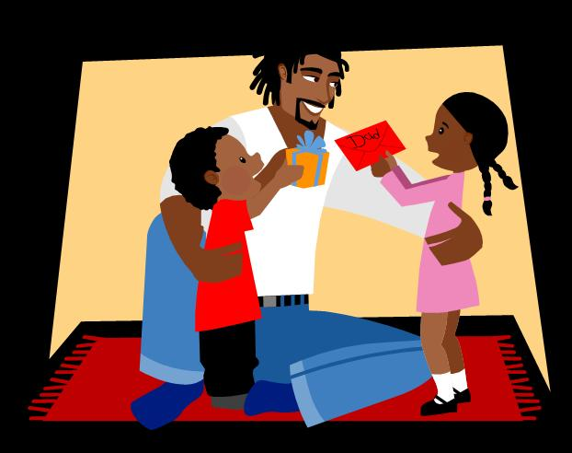
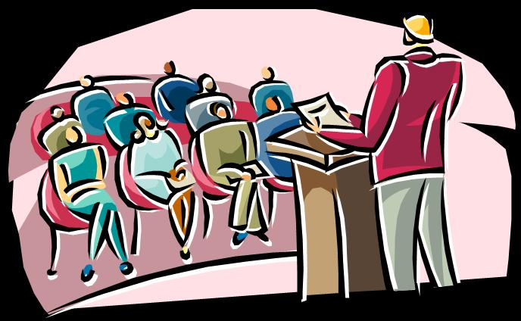
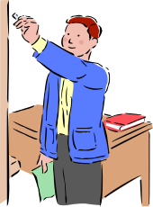

RESOURCES FOR ACTIVITY 6: – Scenario Card B

Role Play

SCENARIO B

Instructions:

- Read the scenario below and assign one of the roles below to each person in the group (one of you should act as scribe, while the rest take part in the role play).
- You may use the character prompts to familiarise yourself with your role before the role play.
- Perform the role play in your groups, remember to stay in character, raising the points you think that character would raise.
- The scribe should take notes on the points raised, throughout the role play so that they can feedback to the rest of the class.

Scenario:

You have been invited to a meeting called by the NHS to discuss whether genetic testing should be offered to parents expecting their first child.

Roles:

- A future parent
- A parent of a child with Down’s Syndrome
- A carrier of the Cystic Fibrosis gene
- A doctor

You need to present at least 5 pros and 5 cons on the matter during your meeting.

NOTE: The prompts for each role are hypothetical; science cannot yet tell us exactly how much genetic profiles can reveal about a person, apart from specific disease risks and certain physical traits.
1) A future parent.

Prompts:
- A genetic profile might reveal information about your baby’s health and physical and mental aptitude. It could indicate level of intelligence, addictive tendencies, learning disabilities, health conditions and behavioural tendencies.
- You are interested in your baby’s health and perhaps you want to prepare as best you can for when it is born.
- You may have a family history of a genetically inherited condition and would/would not consider aborting if your baby had this condition.
- You may be concerned about who will have access to the information and whether it will affect your child later on.
- You may be worried about the child finding out about the genetic profile when he/she is older (will he/she feel like his/her rights were ignored?)

RESOURCES FOR ACTIVITY 6: – Character prompts for Scenario B
1) The parent of a child with Down’s Syndrome.

Prompts:
- A genetic profile might reveal information about a baby’s health and physical and mental aptitude. It could indicate level of intelligence, addictive tendencies, learning disabilities, health conditions and behavioural tendencies.
- You may feel that a genetic test encourages discrimination against people with genetically inherited conditions
- You may/may not have wanted this kind of test to have been available to you before you had your own child
- You may be concerned that society is more interested in decreasing the occurrence of disability rather than providing better facilities for the disabled

1) A carrier of the Cystic Fibrosis gene.

Prompts:
- Cystic Fibrosis is a genetically inherited condition that affects the liquid production in the body (mucus, sweat etc). People with the condition produce liquids that are too thick and not fluid enough. It affects the lungs so severely that lung transplants are often necessary. When both partners carry a cystic fibrosis gene the chance of having a child with cystic fibrosis is 1 in 4.
- A genetic profile might reveal information about a baby’s health and physical and mental aptitude. It could indicate level of intelligence, addictive tendencies, learning disabilities, health conditions and behavioural tendencies.
- A genetic profile would also show whether a child has cystic fibrosis so this may be of particular interest to you

1) A doctor.

Prompts:
- A genetic profile might reveal information about a baby’s health and physical and mental aptitude. It could indicate level of intelligence, addictive tendencies, learning disabilities, health conditions and behavioural tendencies.
- Is the increase in genetic tests going to cost the NHS more?
- Is it going to help doctors prevent disease before it happens or will it increase anxiety in patients?
- Will you be able to tailor treatments to patient’s genetic profiles?

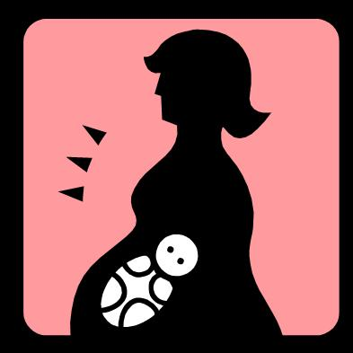
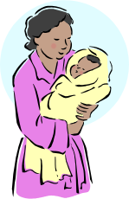
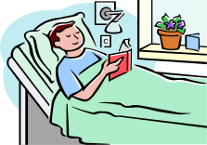
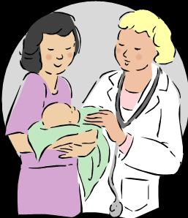

RESOURCES FOR ACTIVITY 6: – Scenario Card C

Role Play

SCENARIO C

Instructions:

- Read the scenario below and assign one of the roles below to each person in the group (one of you should act as scribe, while the rest take part in the role play).
- You may use the character prompts to familiarise yourself with your role before the role play.
- Perform the role play in your groups, remember to stay in character, raising the points you think that character would raise.
- The scribe should take notes on the points raised, throughout the role play so that they can feedback to the rest of the class.

Scenario:

You are a member of a panel appointed by the Government to decide whether all peoples’ genetic profiles should be kept in a national gene bank.

Roles:

- A person who has been told that they are at high risk of heart disease
- An employer in a big chemistry lab
- A student applying for student loans
- The victim of a burglary, whose intruder was caught with the help of forensic genetic testing

You need to present at least 5 pros and 5 cons on the matter during your meeting.

NOTE: The prompts for each role are hypothetical; science cannot yet tell us exactly how much genetic profiles can reveal about a person, apart from specific disease risks and certain physical traits.
1) A person who has been told that they are at high risk of heart disease.

Prompts:
- A genetic profile might reveal information about your health and physical and mental aptitude. It could indicate level of intelligence, addictive tendencies, learning disabilities, health conditions and behavioural tendencies.
- Heart disease often has strong genetic links: 80% of heart disease patients have the same blood cholesterol as people who do not develop heart disease.
- You may be concerned about your condition being genetically based
- You may be concerned about people accessing this database and finding out about your condition (like insurance companies or employers)
- On the other hand you may find it beneficial for medical professionals to have access to your profile in case it helps in treating your heart condition.

RESOURCES FOR ACTIVITY 6: – Character prompts for Scenario C
1) An employer in a big chemistry lab.

Prompts:

- A genetic profile might reveal information about your employee’s health and physical and mental aptitude. It could indicate level of intelligence, addictive tendencies, learning disabilities, health conditions and behavioural tendencies.
- Having access to this database might help you choose your employees more carefully and avoid putting them at risk; it may indicate allergies to certain chemicals for example.
- It may complicate policies on ‘equal opportunities’.

1) A student applying for student loans

Prompts:

- A genetic profile might reveal information about your health and physical and mental aptitude. It could indicate level of intelligence, addictive tendencies, learning disabilities, health conditions and behavioural tendencies.
- You may be concerned that you won’t get your loan if your genetic profile shows that you are at high risk of disease.
- In contrast, it may be easier to get a loan if it indicates you are perfectly healthy.

1) A victim of a burglary, whose intruder was caught with the help of forensic genetic testing.

Prompts:

- Having experienced the benefits of genetic testing you may be particularly interested in a database.
- Will it help fight crime?
- Will it create more fear and violate civil liberties?

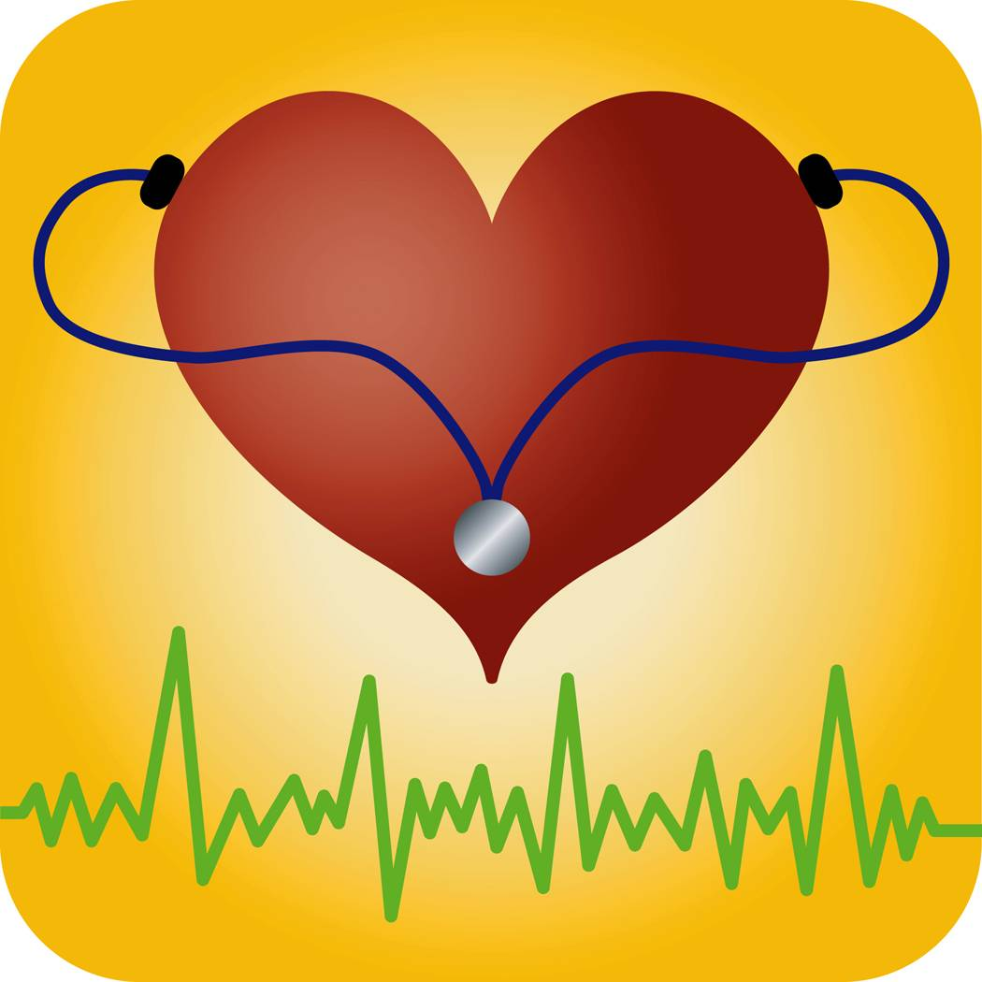


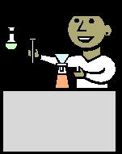

ACTIVITY 7

Genetics Questionnaire



ACTIVITY 7: – Genetics Questionnaire

Curriculum Links:

Science
Pupils should be taught the applications and implications of science:
- About the use of contemporary scientific and technological developments and their benefits, drawbacks and risks.
- To consider how and why decisions about science and technology are made, including those that raise ethical issues, and about the social, economic and environmental effects of such decisions
- How uncertainties in scientific knowledge and scientific ideas change over time and about the role of the scientific community in validating these changes.
PSHE:
- Gain greater knowledge and understanding of spiritual, moral, social and cultural issues through increased moral reasoning, clarifying their opinions and attitudes in discussions with their peers and informed adults and considering the consequences of their decisions.
Citizenship:
- Research a topical political, spiritual, moral, social or cultural issue, problem or event.
- Express, justify and defend orally and in writing a personal opinion about such issues.
- Contribute to group and exploratory class discussions, and take part in formal debate.

Description/Lesson Objectives

This simple questionnaire can be issued as a ‘spot test’ of opinion and then, following further work on the subject, the questionnaire can be re-issued to see how opinions have changed. The activity only takes about 10-15 minutes and does not involve any discussion or feedback. At a later stage it can be looked over again in small groups so that other opinions and ideas can be shared and used to influence personal choice. Feedback can then be given to explore whether, and if so why, people have changed their opinions.

NOTE: We have included several genetic traits in the questionnaire but we recommend you only use around 5 of these traits and choose wisely according to your own acquaintance with your pupils.

How to run this session:

- Hand out the questionnaire (page 51) and ask them to fill in their honest opinions, explaining that it is a personal opinion and that there are no right answers (10 minutes).

- Gather in the questionnaires.

- For further exploration you may wish to divide them into small groups to discuss their answers (15 minutes).

- They should then repeat the questionnaire to see if their answers differ from their original response (5 minutes).

ACTIVITY 7: –Preparation Guidelines and Resources

Genetics Questionnaire

Resources and preparation guidelines:

- Adjust the questionnaire accordingly – we have used a number of genetic traits but you may wish to limit it to 5. We suggest you choose the traits that would cause least disruption in your class.

- Print out enough copies of the questionnaire for each pupil (page 51).

- If you intend to carry out the activity whereby the students discuss the issues and then fill out another questionnaire, you will need to print out 2 copies per student.


For use by teacher or technician, preparing the activity: ‘Genetics Questionnaire’.

RESOURCES FOR ACTIVITY 7: – Genetics Questionnaire

NOTE: These questions are hypothetical and for a few of the conditions/traits mentioned there are no genetic tests to date.

- For which of these conditions would you wish to be tested for?

Genetic Trait | NO | YES
Alcoholism
Cystic Fibrosis
Manic Depression
Obesity
Diabetes
Achondroplasia (Dwarfism)
Dyslexia

- Prenatal testing shows that your future child will have one of the following conditions. How will this affect your decisions?

Genetic Trait | I would terminate the pregnancy | I would prepare and make lifestyle  Changes | I would do nothing and let nature take its course
Alcoholism
Cystic Fibrosis
Manic Depression
Obesity
Diabetes
Achondroplasia(Dwarfism)
Dyslexia
A boy when you wanted a girl or visa versa

- Would you accept to take part in a genetic survey that would tell you about any genetic conditions you have?

TICK BOX
YES, and I would and I would want to know all the information
YES, but I wouldn’t want to know all the information
YES, in the name of scientific research, but I wouldn’t want to know the information
NO, I would refuse to participate

ACTIVITY 8

Fill in Cartoons

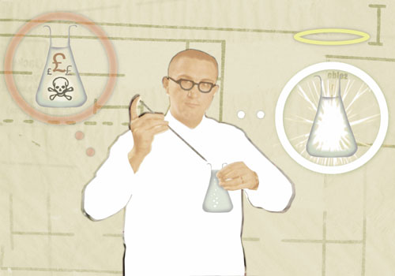

ACTIVITY 8: – Fill in Cartoons

Curriculum Links:

Science
- Discuss the use of contemporary scientific and technological developments and their benefits, drawbacks and risks.
- Consider how and why decisions about science and technology are made, including those that raise ethical issues, and about the social, economic and environmental effects of such decisions
- Understand how uncertainties in scientific knowledge and scientific ideas change over time and about the role of the scientific community in validating these changes.
PSHE:
- Gain greater knowledge and understanding of spiritual, moral, social and cultural issues through increased moral reasoning, clarifying their opinions and attitudes in discussions with their peers and informed adults and considering the consequences of their decisions.
Citizenship:
- Research a topical political, spiritual, moral, social or cultural issue, problem or event.
- Express, justify and defend orally and in writing a personal opinion about such issues.
- Contribute to group and exploratory class discussions, and take part in formal debate.
Description/Lesson Objectives

Some pupils may find this approach more accessible than the detailed debates that have been suggested in this resource pack. The ideas and debates behind genetic profiling and testing are very complex and require a high level of linguistic capability. For some students, these fill-in cartoons are much easier for them to use and express their views, and also to communicate them to others. The session will only take a short time, but follow up work that results from their completion could result in at least 30 minutes. The cartoons themselves are a brief 5-10 minute activity.

How to run this session:

- Set the scene by explaining briefly about genetic testing.

- Divide the class into groups of 2 or 3.

- Give out copies of the fill-in cartoons, with blank spaces in the thought bubbles, along with their accompanying scenarios.

- Give each group pens and/or post it notes to write their responses on.

- Tell the class to look at the cartoon and then imagine what the characters are thinking.

- Alternatively issue copies of the fill-in cartoons with the comments already in the bubbles. The groups are then asked to comment on what they think is the best ‘answer’ to the issue being examined.

- You can then bring the class back together to discuss the comments they came up with.

ACTIVITY 8: –Preparation Guidelines and Resources

Fill in Cartoons

Resources and preparation guidelines:

- Print out copies of the 4 fill-in cartoons and accompanying scenarios. (Pages 55-58).

- You will need enough for one copy per group (they will be split into pairs or triads).

- To give the children more room to write you may wish to print the cartoons out on A3 paper

- Provide felt-tip pens to write in the speech bubbles

- You may wish to provide post-it notes for the group to write on and stick over the speech bubble.


For use by teacher or technician, preparing the activity: ‘Role Play’.

RESOURCES FOR ACTIVITY 8: – Fill in Cartoon 1

CONCEPT CARTOONS
SCENARIO 1

Toby is facing the possibility of a very tough prison sentence. He has been in trouble with the law before, but not for anything serious. At the age of 17 he is alone and frightened and waiting to be released from a young offenders’ institution. His solicitor has just found out that Toby’s mother is in the early stages of Huntington’s disease (HD). Toby’s solicitor has suggested that he takes a genetic test to identify whether he too has HD as that would give them a strong case for demanding leniency.

Prompts:

- Is it ethical to have a genetic test for such purposes?
- Has Toby got enough information about genetic testing and the outcomes in order to make a decision?
- HD usually appears later in life (20’s and above) a genetic test could forecast Toby’s health condition later in his life, is he ready for this information? How will it affect his life and choices?

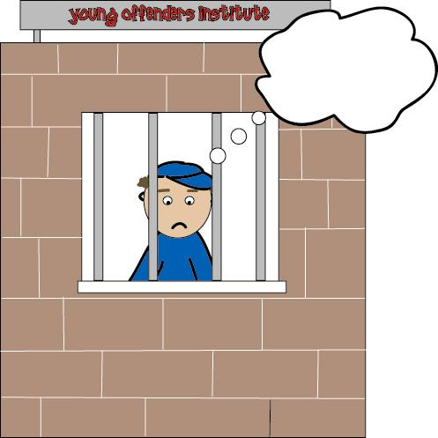

RESOURCES FOR ACTIVITY 8: – Fill in Cartoon 2

CONCEPT CARTOONS
SCENARIO 2

75 year-old Bill has recently taken retirement and is looking forward to hiking in South Wales. He has always been active and healthy but has never had a strict exercise regime. Since his retirement, a few weeks ago, he has had a full medical with his doctor and received some unfortunate news. His heart has developed a slight irregularity, which will probably lead to a heart attack in the next five years. Luckily, Bill is still covered by his company’s health insurance and the doctors have said they can have a new heart grown and fitted for him. Today Bill and his wife June are off to view the half grown heart.

Prompts:

- If you needed an organ transplant would you want to have the new organ grown in the lab from your own cells or would you rather have a donated one?
- If the technology existed to grow new organs cheaply and easily would people start demanding new hearts or lungs without suffering serious medical conditions? (Such as athletes who want better hearts or smokers who would like new lungs).
- How would Bill feel if he was getting someone else’s heart?
- How would June, Bill’s wife, feel if Bill was getting another person’s heart?

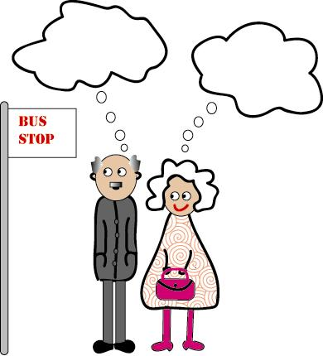

RESOURCES FOR ACTIVITY 8: – Fill in Cartoon 3
CONCEPT CARTOONS
SCENARIO 3

Lucy’s father has recently bought a domestic robot called Eurot. The robot is programmed to do simple domestic tasks like hoovering, window cleaning, ironing and similar house-hold chores. Lucy, who is 16 and in college, likes to call the robot Barney and believes that the robot will one day become intelligent enough to have emotions. Eurot/Barney is sent to the garage when he is not working but Lucy says he should sleep in the house if he’s doing all the dirty tasks in the house.

Prompts:

- Should robots have rights?
- Is Lucy’s father being unfair to Eurot?
- Does Lucy enjoy having Eurot around?
- Would you want to have robots around your house, and how intelligent would you want them to be?
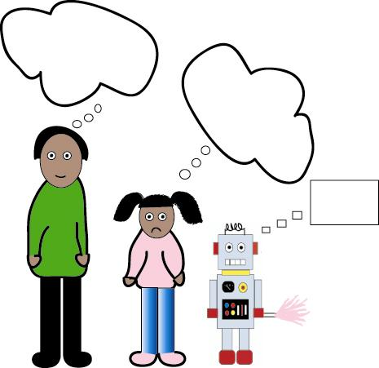

RESOURCES FOR ACTIVITY 8: – Fill in Cartoon 4
CONCEPT CARTOONS
SCENARIO 4

Lindsey (18 years old) is taking some international development classes at college and is part of an online community of students around the world. Lindsey met Sinyama at one of these classes and now has a really strong online friendship with her. Sinyama has invited Lindsey to come visit her in Zambia during the summer holidays. Lindsey would love to go but Zambia is a high risk region for a variety of tropical diseases and Sinyama’s family regularly fall ill. Lindsey can take a new genetic vaccine that provides total protection but she now feels guilty that she can simply take a vaccine as a tourist, while the local people are still dying from these illnesses.

Prompts:

- Why is Lindsey feeling guilty and what would she rather do?
- Why are new drugs and vaccines not easily accessible to all?
- What would you do in Lindsey’s place?
- How do you think Sinyama feels, knowing that Lindsey can easily protect herself, while she and her family fall ill?

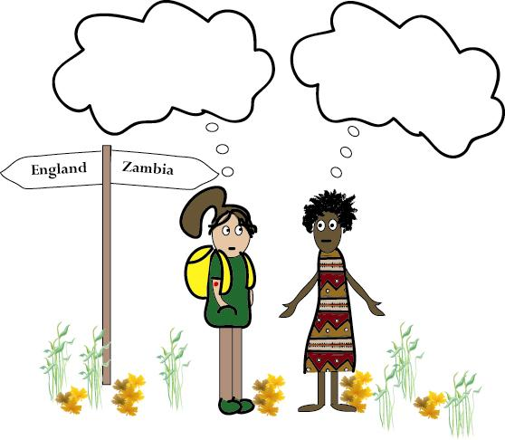

TIPS FOR
ORGANISING GROUP DISCUSSION

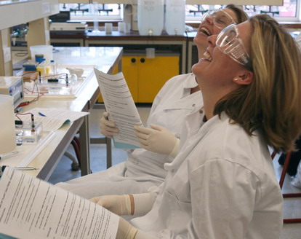

Meet the Gene Machine – Teachers’ Resource Pack

Tips for Organising Group Discussion

Without proper planning, or full student comprehension, small group discussion can quickly descend into chaos. If the task is not clearly defined, some students will do all the talking and decision-making, and others will feel excluded. Reaching early consensus can be a problem, so the topic for discussion has to be set in such a way that, diverse views or ideas are addressed.

The following ideas may be helpful in combating problems and formulating your preferred style.

A few basic tips for successful group discussions:

- Take ideas from teachers of other subjects e.g. English, Drama, RE, Science and Humanities. Each will have a different approach and knowledge transfer is always useful.

- Have a plan for establishing the groups. There are some suggestions overleaf that may be relevant in this context.

- Ensure that roles are clearly defined.

- Explain the rules and give examples.

- Prepare all materials in advance, and check there are sufficient copies available. Using coloured paper will help in quick distribution of the correct materials to each group or individual.

- Tell the group what the expected outcomes should be from the outset, (whether it is a written summary, presentation, poster or other way of communicating their consensus ideas).

- Keep students on task by careful use of timings and reminders.

- Remember that your role as the teacher is to facilitate the process, not necessarily to ‘direct’ it. This is not as easy as it seems, so take advice from those who are used to this approach. Think of neutral questions to ask throughout the discussions and do not take sides. You may even find it necessary to play ‘devil’s advocate’ to stir up further debate.

See overleaf for strategies on organising students into groups.

Meet the Gene Machine – Teachers’ Resource Pack

Strategies for organising group talk:

(Based on Literacy across the curriculum 2001)

Pair talk
Easy to organise, even in cramped classrooms. Promotes high levels of participation, and ensures that the discussions are highly focused, (especially if allied to tight deadlines). Use in the early stages of learning for pupils to recall work from a previous lesson, generate questions, work together to plan a piece of writing, or to take turns to tell a story. Use pairs to promote ‘response partners’ during the drafting process, and to work as reading partners with an unfamiliar text. Ideal for quick-fire reflection and review, and for rehearsal of ideas, before presenting them to the whole class.

Pairs to fours
Pupils work together in pairs – possibly friendship, possibly boy-girl, etc. Each pair then joins up with another pair to explain and compare ideas. Children work well when at least one person from their friendship circle is in their group.

Listening triads
Pupils work in groups of three. Each pupil takes on the role of talker, questioner or recorder. The talker explains something, or comments on an issue, or expresses opinions. The questioner prompts and seeks clarification. The recorder makes notes and gives a report at the end of the conversation. Next time, roles are changed.

Envoys
Once groups have carried out a task, one person from each group is selected as an ‘envoy’ and moves to a new group to explain and summarise, and to find out what the new group thought, decided or achieved. The envoy then returns to the original group and provides feedback. This is an effective way of avoiding tedious and repetitive ‘reporting back’ sessions. It also puts a ‘press’ on the envoy’s use of language and creates groups of active listeners.

Snowball
Pairs discuss an issue, or brainstorm some initial ideas, then double up to fours and continue the process, then into groups of eight in order to compare ideas and to sort out the best or to agree on a course of action. Finally, the whole class is drawn together and spokespersons for each group of eight feedback ideas. A useful strategy to promote more public discussion and debate.

Rainbow groups
A way of ensuring that pupils are regrouped and learn to work with a range of others. After small groups have discussed together, pupils are given a number or colour. Pupils with the same number or colour join up, making groups comprising representatives of each original group.
In their new group pupils take turns to report back on their group’s work and perhaps begin to work on a new, combined task.

Jigsaw
A topic is divided into sections. In ‘home’ groups of four or five, pupils allocate a section each, and then regroup into ‘expert’ groups. In these groups, experts work together on their chosen area, then return to original ‘home’ groups to report back on their area of expertise. The ‘home’ group is then set a task that requires the pupils to use the different areas of ‘expertise’ for a joint outcome. This strategy requires advance planning, but is a very effective speaking and listening strategy because it ensures the participation of all pupils.

Spokesperson

Each group appoints a spokesperson. The risks of repetition can be avoided if:

  - One group gives a full feedback, and others offer additional points only if they have not been covered.

  - Each group is asked in turn to offer one new point until every group ‘passes’.

  - Groups are asked to summarise their findings on A3 sheets which are then displayed. The class is invited to compare and comment on them.

APPENDICES



Appendix 1: Meet the Gene Machine and the Curriculum
Appendix 2: Glossary of Terms

APPENDIX 1 – Meet The Gene Machine & The Curriculum

APPENDIX 1: Meet the Gene Machine applications within the curriculum

Key themes: Genetics, Genetic diseases, Genetic screening and Genetic Profiling. Ethical and Moral consideration; impact of science in society.

SCIENCE:

The Meet the Gene Machine programme offers the opportunity to incorporate all of these new science requirements:

- provide science which is engaging and exciting
- include opportunities for discussion and debate of science issues
- be set in contexts which reflect contemporary science issues and are relevant to pupils’ experiences and present and future lives
- include more opportunities for enquiries which are pupil-led (not formulaic)
- enable pupils to build, explore and apply their understanding of science rather than just learn about some science
- require pupils to make more use of secondary data and information such as can be obtained through the Internet

(Items in bold are particularly well matched to Meet the Gene Machine objectives).

The New Programme of Study for KS4 Science states: During Key Stage 4, pupils learn about the way science and scientists work within society. They consider the relationships between data, evidence, theories and explanations and develop their practical, problem-solving and enquiry skills, working individually and in groups. They evaluate enquiry methods and conclusions both qualitatively and quantitatively, and communicate their ideas with clarity and precision. All pupils develop their ability to relate their understanding of science to their own and others’ decisions about lifestyles, and to scientific and technological developments in society.

The national curriculum also sets out where learning should take place across the curriculum. The four areas for learning, which are described in more detail in the national curriculum handbooks, are:

- Promoting spiritual, moral, social and cultural development across the national curriculum
- Promoting Personal, Social and Health Education (PSHE)
- Promoting skills across the national curriculum (e.g. key skills and thinking skills)
- Promoting other aspects of the school curriculum (e.g. financial capability and education for sustainable development).

The national curriculum also sets out two areas that must be taught across the curriculum. These are:

- Use of language (reading, writing, speaking, listening)
- The use of information and communication technology

CITIZENSHIP

Students should be taught to:
- research a topical political, spiritual, moral, social or cultural issue, problem or event by analysing information from different sources, including ICT-based sources, showing an awareness of the use and abuse of statistics
- express, justify and defend orally and in writing a personal opinion about such issues, problems or events
- contribute to group and exploratory class discussions, and take part in formal debates.

English

Speaking and listening
Students should be taught to:
- talk clearly, using markers so that their listeners can follow the line of thought
- use illustrations, evidence and anecdote to enrich and explain their ideas
- use gesture, tone, pace and rhetorical devices for emphasis
- use visual aids and images to enhance communication
- vary word choices, including technical vocabulary, and sentence structure for different audiences

Printed and ICT-based information texts
Students should be taught to:
- select, compare and synthesise information from different texts
- evaluate how information is presented
- sift the relevant from the irrelevant, and distinguish between fact and opinion, bias and objectivity

Composition
Students should be taught to:
- develop logical arguments and cite evidence
- use persuasive techniques and rhetorical devices
- anticipate reader reaction, counter opposing views and use language to gain attention and sustain interest
- reflect on the nature and significance of the subject matter
- form their own view, taking into account a range of evidence and opinions
- organise their ideas and information, distinguishing between analysis and comment

Drama

Students should be taught to:
- use a variety of dramatic techniques to explore ideas, issues, texts and meanings

PSHE

Students should be taught to consider social and moral dilemmas (for example, young parenthood, genetic engineering, attitudes to the law). They gain greater knowledge and understanding of spiritual, moral, social and cultural issues through increased moral reasoning, clarifying their opinions and attitudes in discussions with their peers and informed adults and considering the consequences of their decisions.

APPENDIX 2 – Glossary of Terms Relating to Genetic Testing

APPENDIX 2: GLOSSARY OF TERMS

Acquired mutations: | gene changes that arise within individual cells and accumulate throughout a person's lifetime; also called somatic mutations. (See Hereditary mutation.)
Alleles: | variant forms of the same gene. Different alleles produce variations in inherited characteristics such as eye colour or blood type.
Alzheimer's disease: | a disease that causes memory loss, personality changes, dementia and, ultimately, death. Not all cases are inherited, but genes have been found for familial forms of Alzheimer's disease.
Amino acid: | any of a class of 20 molecules that combine to form proteins in living things.
Autosome: | any of the non-sex-determining chromosomes. Human cells have 22 pairs of autosomes.
Base pairs: | the two complementary, nitrogen-rich molecules held together by weak chemical bonds. Two strands of DNA are held together in the shape of a double helix by the bonds between their base pairs. (See Chemical base.)
BRCA1 breast cancer susceptibility gene: | a mutated version of BRCA1, which predisposes a person toward developing breast cancer.
Carrier: | a person who has a recessive mutated gene, together with its normal allele. Carriers do not usually develop disease but can pass the mutated gene on to their children.
Carrier testing: | testing to identify individuals who carry disease-causing recessive genes that could be inherited by their children. Carrier testing is designed for healthy people who have no symptoms of disease, but who are known to be at high risk because of family history.
Cell: | small, watery, membrane-bound compartment filled with chemicals; the basic subunit of any living thing.
Chemical base: | an essential building block. DNA contains four complementary bases: adenine, which pairs with thymine, and cytosine, which pairs with guanine. In RNA, thymine is replaced by uracil.
Chromosomes: | structures found in the nucleus of a cell, which contain the genes. Chromosomes come in pairs, and a normal human cell contains 46 chromosomes, 22 pairs of autosomes and two sex chromosomes.
Clone: | a group of identical genes, cells, or organisms derived from a single ancestor.
Cloning: | the process of making genetically identical copies.
Colonoscopy: | examination of the colon through a flexible, lighted instrument called a colonoscope.
Crossing over: | a phenomenon, also known as recombination, that sometimes occurs during the formation of sperm and egg cells (meiosis); a pair of chromosomes (one from the mother and the other from the father) break and trade segments with one another.
Cystic fibrosis: | an inherited disease in which a thick mucus clogs the lungs and blocks the ducts of the pancreas.
Cytoplasm: | the cellular substance outside the nucleus in which the cell's organelles are suspended.
Dementia: | severe impairment of mental functioning.
DNA: | the substance of heredity; a large molecule that carries the genetic information that cells need to replicate and to produce proteins.
DNA sequencing: | determining the exact order of the base pairs in a segment of DNA.
Dominant allele: | a gene that is expressed, regardless of whether its counterpart allele on the other chromosome is dominant or recessive. Autosomal dominant disorders are produced by a single mutated dominant allele, even though its corresponding allele is normal. (See Recessive allele.)
Enzyme: | a protein that facilitates a specific chemical reaction.
Familial adenomatous polyposis: | an inherited condition in which hundreds of potentially cancerous polyps develop in the colon and rectum.
Familial cancer: | cancer, or a predisposition toward cancer, that runs in families.
Familial hypercholesterolemia | : A dominantly inherited genetic condition that results in markedly elevated LDL (low-density lipoprotein) cholesterol levels beginning at birth, and cause heart attacks at an early age.
Functional gene tests: | biochemical assays for a specific protein, which indicates that a specific gene is not merely present but active.
Gene: | a unit of inheritance; a working subunit of DNA. Each of the body's 20,000 to 25,000 genes contains the code for a specific product, typically, a protein such as an enzyme. (Revised: October 2004)
Gene deletion: | the total loss or absence of a gene.
Gene expression: | the process by which a gene's coded information is translated into the structures present and operating in the cell (either proteins or RNAs).
Gene markers: | landmarks for a target gene, either detectable traits that are inherited along with the gene, or distinctive segments of DNA.
Gene mapping: | determining the relative positions of genes on a chromosome and the distance between them.
Gene testing: | examining a sample of blood or other body fluid or tissue for biochemical, chromosomal, or genetic markers that indicate the presence or absence of genetic disease.
Gene therapy: | treating disease by replacing, manipulating, or supplementing non-functional genes.
Genetic linkage maps: | DNA maps that assign relative chromosomal locations to genetic landmarks either genes for known traits or distinctive sequences of DNA - on the basis of how frequently they are inherited together. (See Physical maps.)
Genetics: | the scientific study of heredity: how particular qualities or traits are transmitted from parents to offspring.
Genetic screening: | (Genetic testing) is the genetic diagnosis of genetically inherited diseases, and can also be used to determine a person's ancestry.
Genome: | all the genetic material in the chromosomes of a particular organism.
Genome maps: | charts that indicate the ordered arrangement of the genes or other DNA markers within the chromosomes.
Genomics: | The study of genes and their function.
Genotype: | the actual genes carried by an individual (as distinct from phenotype that is, the physical characteristics into which genes are translated).
Germ cells: | the reproductive cells of the body, either egg or sperm cells.
Hereditary mutation: | a gene change in the body's reproductive cells (egg or sperm) that becomes incorporated in the DNA of every cell in the body; also called germ line mutation. (See Acquired mutations.)
Human genome: | the full collection of genes needed to produce a human being.
Human Genome Project: | an international research effort aimed at identifying and ordering every base in the human genome.
Huntington's disease: | an adult-onset disease characterized by progressive mental and physical deterioration; it is caused by an inherited dominant gene mutation.
Leukaemia: | cancer that begins in developing blood cells in the bone marrow. a cancer that begins in skin cells called melanocytes and spreads to internal organs.
Molecule: | a group of atoms arranged to interact in a particular way; one molecule of any substance is the smallest physical unit of that particular substance.
Mutation: | a change in the number, arrangement, or molecular sequence of a gene.
Newborn screening: | examining blood samples from a newborn infant to detect disease-related abnormalities or deficiencies in gene products.
Nucleotide: | A subunit of DNA or RNA, consisting of one chemical base plus a phosphate molecule and a sugar molecule.
Nucleus: | the cell structure that houses the chromosomes.
Oncogenes: | genes that normally play a role in the growth of cells but, when over expressed or mutated, can foster the growth of cancer.
Penetrance: | term indicating the likelihood that a given gene will actually result in disease.
Phenylketonuria (PKU): | an inborn error of metabolism caused by the lack of an enzyme, resulting in abnormally high levels of the amino acid phenylalanine; untreated, PKU can lead to severe, progressive mental retardation.
Physical maps: | DNA maps showing the location of identifiable landmarks, either genes or distinctive short sequences of DNA. The lowest resolution physical map shows the banding pattern on the 24 different chromosomes; the highest resolution map depicts the complete nucleotide sequence of the chromosomes.)
Precancerous polyps: | growths in the colon that often become cancerous.
Predictive gene tests: | tests to identify gene abnormalities that may make a person susceptible to certain diseases or disorders.
Prenatal diagnosis: | examining foetal cells taken from the amniotic fluid, the primitive placenta (chorion), or the umbilical cord for biochemical, chromosomal, or gene alterations.
Prophylactic surgery: | surgery to remove tissue that is in danger of becoming cancerous, before cancer has the chance to develop. Surgery to remove the breasts of women at high risk of developing breast cancer is known as prophylactic mastectomy.
Protein: | a large, complex molecule composed of amino acids. The sequence of the amino acids and thus the function of the protein is determined by the sequence of the base pairs in the gene that encodes it. Proteins are essential to the structure, function, and regulation of the body. Examples are hormones, enzymes, and antibodies.
Protein product: | the protein molecule assembled under the direction of a gene.
Recessive allele: | a gene that is expressed only when its counterpart allele on the matching chromosome is also recessive (not dominant). Autosomal recessive disorders develop in persons who receive two copies of the mutant gene, one from each parent who is a carrier. (See Dominant allele.)
Recombination: | (See Crossing over.)
Renal cell cancer: | a type of kidney cancer.
Reproductive cells: | egg and sperm cells. Each mature reproductive cell carries a single set of 23 chromosomes.
Restriction enzymes: | enzymes that can cut strands of DNA at specific base sequences.
Retinoblastoma: | an eye cancer caused by the loss of a pair of tumour-suppressor genes; the inherited form typically appears in childhood, since one gene is missing from the time of birth.
RNA: | a chemical similar to DNA. The several classes of RNA molecules play important roles in protein synthesis and other cell activities.
Sarcoma: | a type of cancer that starts in bone or muscle.
Screening: | looking for evidence of a particular disease such as cancer in persons with no symptoms of disease.
Sex chromosomes: | the chromosomes that determine the sex of an organism. Human females have two X chromosomes; males have one X and one Y.
Sickle-cell anaemia: | an inherited, potentially lethal disease in which a defect in haemoglobin, the oxygen-carrying pigment in the blood, causes distortion (sickling) and loss of red blood cells, producing damage to organs throughout the body.
Somatic cells: | all body cells except the reproductive cells.
Somatic mutations: | (See Acquired mutations.)
Tay-Sachs disease: | an inherited disease of infancy characterized by profound mental retardation and early death; it is caused by a recessive gene mutation.
Transcription: | the process of copying information from DNA into new strands of messenger RNA (mRNA). The mRNA then carries this information to the cytoplasm, where it serves as the blueprint for the manufacture of a specific protein.
Translation: | the process of turning instructions from mRNA, base by base, into chains of amino acids that then fold into proteins. This process takes place in the cytoplasm, on structures called ribosomes.
Tumour-suppressor genes: | genes that normally restrain cell growth but, when missing or inactivated by mutation, allow cells to grow uncontrolled.
X chromosome: | a sex chromosome; normal females carry two X chromosomes.
Y chromosome: | a sex chromosome; normal males carry one Y and one X chromosome.

