RESEARCH BRIEFING SHEET

Version: 24.04.14
Start: 01.09.12 End: 31.03.14

ChoiceRail – Finding the best Rail Journeys

Background
ChoiceRail looks to provide travellers with a new way of finding travel options for longer distance journeys (those over 50m / 80kms) in the UK. It developed in response to the ‘Accelerating Innovation in Rail’ funding call from the UK Technology Strategy Board and the Rail Safety and Standards Board (RSSB). This call looked for technology innovation to address challenges facing the UK rail industry and to develop solutions for the UK and international rail markets. The project focussed specifically on the theme of ‘improving the customer experience’ through new information services. The project business partners, Cotares, Trapeze and Inrix have developed the ChoiceRail planner, drawing on their skills in journey planning and provision of travel data for road and public transport. For its part, the Centre for Transport and Society (CTS) has contributed to the project in respect of the ‘use’ and ‘usability’ of the new planner, drawing on many years of experience in travel behaviours, including that gained through earlier work on Transport Direct for the UK Government.

The ChoiceRail planner
ChoiceRail presents the traveller with a set of journey options, reflecting the fact that there may be several possible access points (stations) for a trip involving rail, with pros and cons for using local, intermediate or distant stations. With this in mind, the planner has been developed to offer:
- Consistent delivery of optimum route and mode combinations across four distinct journey types (‘kiss-and-ride’, ‘park-and-ride’, stations part-way and drive only). With ‘optimum’ reflecting user criteria such as journey time, changes, CO2 emissions or potentially cost in the future.
- Full door-to-door planning incorporating ‘last-mile’ information (walk, bus), and other important real-life factors for end to end journey planning such as parking availability.
- Awareness of time-dependent and real-time road / rail conditions (reflecting the time and day the journey is being made).
- The ability to find alternate journeys using a range of rail access points, some of which may be less-obvious to the traveller, and which would not be seen in single-mode planners where origin / destination stations have to be explicitly defined.
- Real time planning, meaning ChoiceRail can also provide in-trip advice – i.e. advising a car user to divert to a railway station to avoid congestion.
- Support for ‘open’ data, including public transport information under the Open Data Initiative, as well as OpenStreetMap.
- An architecture supporting implementation in-car, avoiding a need to potentially plan twice.
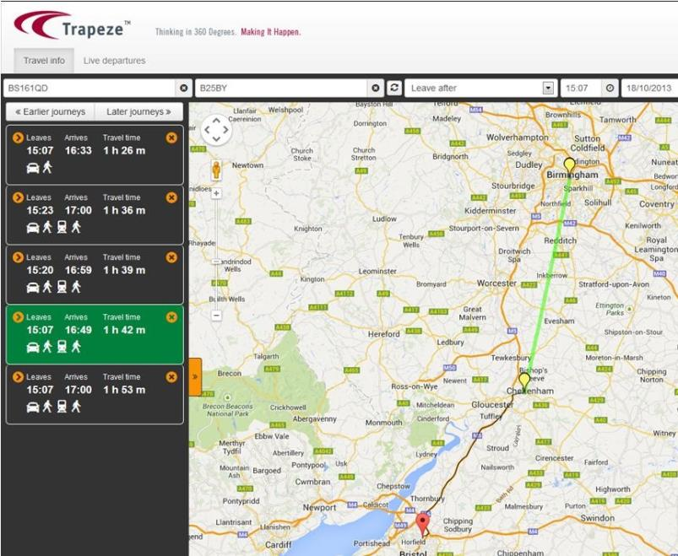
Underpinning this functionality is a new and highly innovative algorithm which when combined with (real time) road and rail data feeds is able to offer travellers a concise and easy to understand set of journey choices, moving beyond the simple timetable and route information of traditional planners.

Research approach
CTS provided insights to the project concerning how and when travellers might use travel information systems, and carried out new research (focus groups and interviews) with members of the public to see how they responded to the novel approach offered by ChoiceRail.
Initially the concept was tested through four focus groups with participants who regularly made longer distance journeys. The groups reflected a mix of age, occupation, travel mode and gender, and followed a semi-structured format. Six interviews were also carried out with individuals working in the project. These allowed the attitudes of people who were both longer-distance travellers and familiar with the technical concepts involved to be explored. The outputs from both steps provided input to development of a working prototype of the new planner. CTS subsequently undertook twenty ‘think-aloud’ interviews, a technique common in the field of software testing. This allowed participants to ‘try’ the software in question (here a version of ChoiceRail), and then undertake a more reflective interview immediately afterwards. Interviewees were split 50:50 regular rail users, and car users for longer distance (business) journeys. Some participants were new to ChoiceRail, whilst others had taken part in the focus groups – helping to again check the effect of familiarity.

Outcomes
The focus groups discussed ChoiceRail as a ‘concept’ and the reaction to the journeys offered was often negative and focussed on potential problems and complications of achieving mixed-mode journeys. Habitual car users in the groups were particularly reluctant to consider such an option. For a few people (especially those already driving to stations) there was some support for thinking about rail access further along a route or perhaps on an alternate route. Benefits were often seen for others, and not for participants themselves, and were more apparent in unfamiliar locations – including journeys outside of the UK. For most of the participants in most of the groups, it seems that the concept of mixed-mode journeys was perhaps more suited for niche applications rather than mainstream business and leisure travel.
The ‘think-aloud’ interviews offered participants the chance to actually plan a journey with a working prototype. This offered an opportunity to gauge reactions, as well as providing a range of usability information to be fed back to the developers of the software / service. Most of the interviewees seemed open to and appreciative of the mixed-mode journey options that ChoiceRail produced and that these sorts of journeys may have positive virtues in some instances. They also understood the fact that algorithms underpinning the planner had produced a spread of journey types as opposed to merely a set of similar journeys from point A to point B at different times. It seems though that even with real-life examples there was still a reluctance (amongst this group at least) to accept travelling further to access a rail station, or to embrace mixed-mode journeys in any significant way. By contrast there did seem to be some interest in the idea of park-and-ride options, particularly for London and for other city centres. There was also a very positive reaction to the ability to incorporate last-mile information.
Many participants suggested that they might use ChoiceRail, albeit with caveats, or expressed more in terms of ‘thinking about’ use. Clear narratives about how it could be used as both an information aggregator and as a travel ‘explorer’ emerged from the reflective interviews (especially for car drivers). It was apparent though that for some people there would need to be an incentive for them to use ChoiceRail over existing tools, and to this end functionality and content might need to be enhanced. However, with additional features, and if the complexity of use and solutions was managed appropriately there would be a potential market for such a system amongst longer-distance travellers.
Some key messages emerging from the study:
- People can envisage use-cases for a ChoiceRail type mixed-mode planner
- More information is needed (especially price)
- It would need to be as good as the competition (multi or single mode)
- ‘Park and ride’ currently most interesting
- Enthusiasm is tempered by perceived barriers
The project has been successful, reaching its goal of a working prototype. We look forward to real-life deployment of the planner, and how the interest shown here in this research might translate into use for mixed-mode journeys.

Contact details
Professor Glenn Lyons
Glenn.lyons@uwe.ac.uk Tel: 0117 32 83219
Ian Shergold
Ian2.shergold@uwe.ac.uk Tel: 0117 32 81178
Centre for Transport & Society
Faculty of Environment & Technology
University of the West of England
Frenchay Campus
Coldharbour Lane
BRISTOL BS16 1QY
UNITED KINGDOM
www.uwe.ac.uk/research/cts

