Electronic Accreditation of Experiential Learning (eAEL) at UWE

'Gaining credit for your experience

Contents

 | Page
Introduction | 3
What is AEL? | 3
Getting started | 4
Learning ambitions | 5
Experience | 6
The learning tab | 8
Reviewing your proposal | 13
Formative feedback | 14
The criteria that must be met and how we assess them | 15
Frequently asked questions | 16

Introduction
This guide aims to assist students in completing their eAEL application for UWE. There is guidance available on the on-line tool itself and this guide supports and extends that advice and also gives some information about how to get the most from your claim.

What is AEL?
AEL stands for Accreditation of Experiential Learning. AEL is defined as;
Learning achieved through experience gained by an individual outside formalised learning arrangements where the learning outcomes are open to assessment by the University.
AEL recognises that throughout our working lives the majority of learning that we achieve for work is undertaken at work, and this often goes unrecognised
There are different ways of doing this. One way involves students looking at the learning outcomes of a specific module and claiming that she is able to meet these. Assessment is by negotiation but is directed at the learning outcomes of that module. Often, but not always, it means doing the assessment task, perhaps an assay or a report.

A second way is make a more general claim about your learning. This does not test your ability to meet specific outcomes but asks that you claim that you have acquired knowledge, often during your work, and that this has equipped you with certain skills. Your claim is that you have these skills and the on line tool helps you articulate what skills you have and provide evidence in support.

Case study – Janice, band 6 nurse in a Coronary care Unit

Janice started completed her training some time ago before initial nurse registration required university study. Since that time she has constantly learned clinical, educational and leadership skills, and is acknowledged to be a very effective team leader. However, apart from teaching and assessing modules she has no recognised academic qualifications.

Getting started
First you need to register on the on line tool. You can do this for free – the fee for registration and accreditation is payable prior to the assessment of your learning

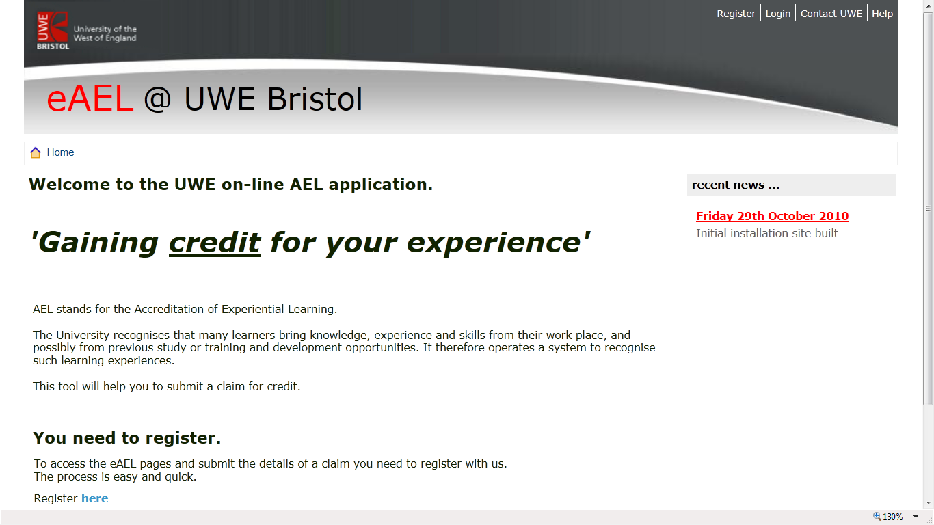
The information box says that you should enter your UWE e mail, and you should do this is you have one as official e mails will be sent there. But it’s possible that you haven’t got a UWE e mail address yet in which case you can use any e mail address. It will also ask you for a student number and you won’t be able to proceed without one. If you have not registered as a UWE student you can put any number here and update it later – this will allow you to proceed.
Once you are registered on the tool, you will be able to log in using your e mail address and password.
Once you have pressed ‘save and continue’ you will get access to the next tab, which asks you to enter your qualifications. You can only add one qualification to this page, so it should be your highest qualification.
The next page asks for your CV. If you haven’t got this to hand or are developing it and want to upload it later, just press ‘save and continue’ and you can access the next page which asks about your ambitions.

Learning Ambitions
This page asks you to place your past learning in the context of your wider ambitions.
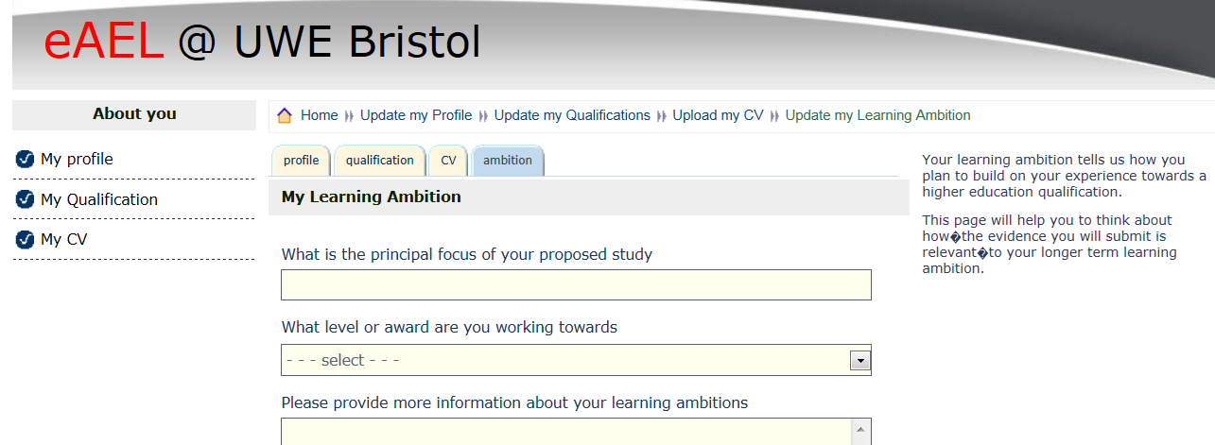

The first question refers to your study in the broad sense rather than a particular piece of planned or completed work.
Janice’s story
Janice has entered that her principal focus is that she wishes to consolidate her learning and progress towards a degree so that she can apply for a band 7 post, and so her level of award is degree with honours. In may be possible for someone working at her level that she is already working at Master’s level – you don’t always need a first degree to claim Master’s level credit or be accepted on a Master’s award.
The section on learning ambitions has enabled to Janice to explain where she she’s her career developing and what learning she thinks she needs to facilitate this. It also allows her to explain how what she has already learnt (and is about to claim credit for) link to where she is now, and where she hopes to get to.
When you have taken the time to articulate and present the evidence that you are claiming for, you may wish to return to this section prior to submission. For now, in order to progress to the next section you have to enter something into the boxes but you can return to this later.
This completes the ‘about you section’ – the next section is about your experience.

Experience
This section is the main part of what you need to do. Your learning is mapped against a number of descriptors under four headings:
- Knowledge and Understanding
- Intellectual skills
- Professional and practical skills
- Transferable skills
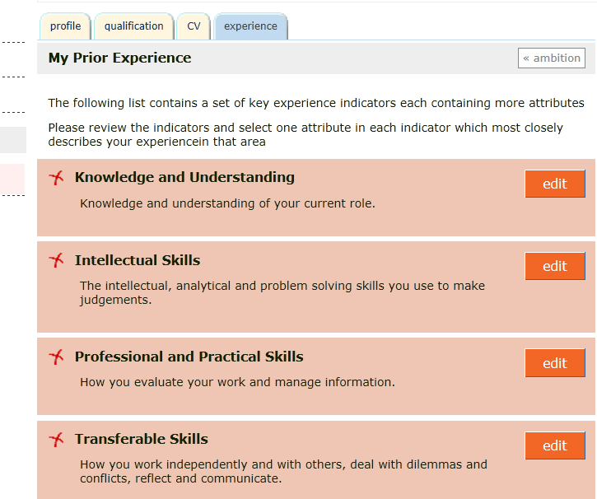
These broad headings have been broken down further. When you click the edit button the sub headings are revealed. The sub headings are;
- Knowledge and Understanding
  - Context
  - Evaluating information
  - Interpreting
- Intellectual skills
  - Problem solving
  - Developing new systems
- Professional and Practical Skills
  - Evaluation
  - Management of Information
- Transferable skills
  - Working independently and with others
  - Dilemmas and Conflicts
  - Reflections on action and practical skills
  - Communication and reflexivity
There are now 11 headings against which you can map your experience.
For each of these headings a sequence of statements are presented at levels 1, 2, 3 and M. These have been written so that they are equivalent to academic levels.
- Level 1 is equivalent to a Certificate in Higher Education (CertHE)
- Level 2 is equivalent to a Diploma in Higher Education (DipHE)
- Level 3 is equivalent to a Bachelor’s degree BA/BSc
- Level M is equivalent to a Master’s degree MA/MSc

These are nationally recognised and regulated qualifications. You can read more about different academic levels here
The statements often are written in terms of what you can do as well as what you know. For example for Problem Solving the statements are;

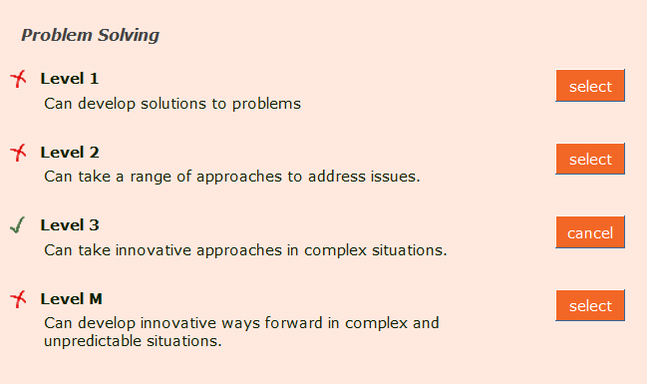

I have claimed that in problem solving my skills are at level 3.
Your claim requires you to assess your knowledge and skills against each of these 11 statements. When you have made this self-assessment, there will be a green tick against the four domains and the learning tab will appear at the top of the screen.
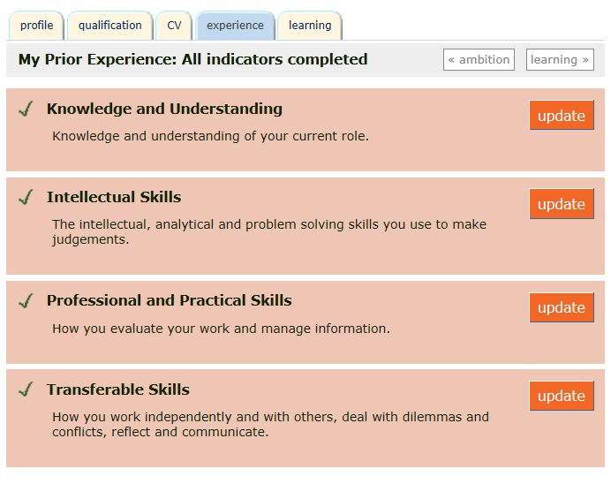

You can begin to provide evidence that you have done what you say you can do. Remember you need to provide evidence for your learning. When you have completed your assessment of what you can do you can move on to the learning tab or the button at the top.
The Learning Tab.
This is the section of the eAEL tool that helps you to organise you learning. It is the most important section for your claim, the section that is marked. Each experience of prior learning requires you to complete the three sections
- Statement details – this provides an overview of the experience
- Statement evidence – This allows you to upload evidence which demonstrates learning.
- Experience commentary – this allows you to explain how the evidence uploaded demonstrates that you have met the outcomes.
Remember – your evidence must demonstrate the skills that you say that you have. When your claim is assessed (that is, marked) the marker will judge whether the evidence that you have presented demonstrates the skills.
Let’s work through an example using Janice’s story. An experience that Janice wishes to use is the development of a patient information leaflet
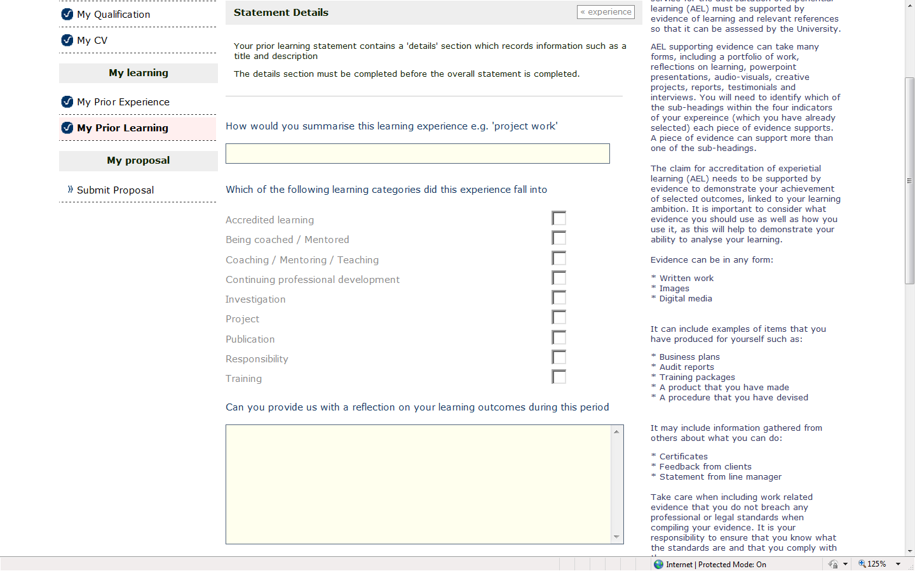
Janice would start on the details page and enter something like that the summary is providing a patient information leaflet, and that this was a project.
The reflection section asks for a contextualising details, placing the experinece in the context of your ambition. If part of the evidence is a piece of critical reflection, this can be uploaded as part of your evidence
After you have clicked the button at the botton marked ‘update details’ a further button marked evidence will appear at the top of the page

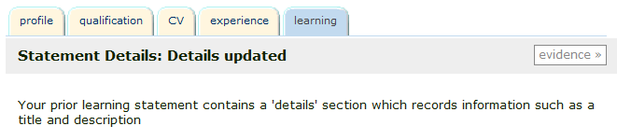
When you click on this you are enabled to upload evidence after you have described what it is
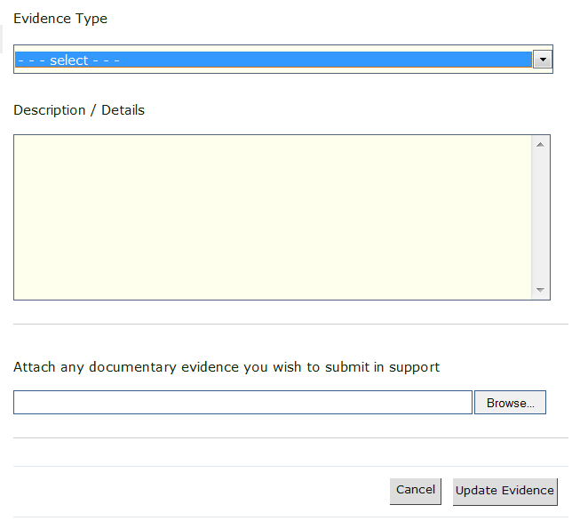
Top Tip
The maximum file size for a single piece of evidence is about 500KB. If your pdf or presentation is more than this, refer to FAQs page XX
Top Tip
Use a descriptive file name to help identification later

This does of course mean that the evidence must be in electronic format and this means that if you have evidence in the form, say of a written testimonial from a patient, you may have to get the document scanned – and this will also give you the opprtunity of ensuring that personal details are not included.
Once this has been uploaded you can update additional evidence as required but you won’t see all of the evidence that you have uploaded until you have moved on to the commentary section. Then each piece of evidence will be listed.
Top Tip
You won’t be able to upload evidence until the boxes are completed.
Janice has uploaded four pieces of evidence;

It takes a bit of time to get used to how to tab to the difference sections for each learning experience, but when you have uploaded your evidence you can go to the commentary section by clicking the tab
Top Tip
Press any button with update on and your entry will be saved. You can also use these buttons to help navigate round the tool

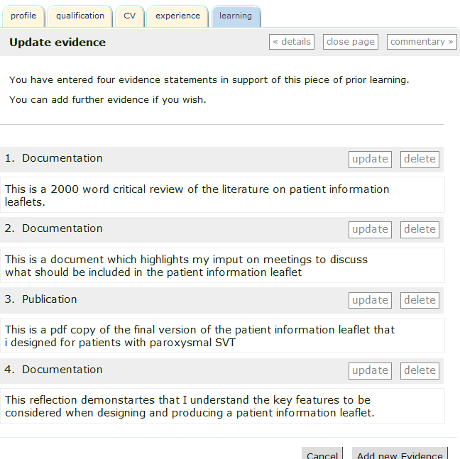

Having uploaded the pieces of evidence, the final part requires Janice to give a commentary which explains why the evidence uploaded demonstartes the skills that she has claimed to have.
When you ress the commentary button, you are directed to a page which has boxes for you to enter text. The levels have already been set at theones that you identified in the experinece section
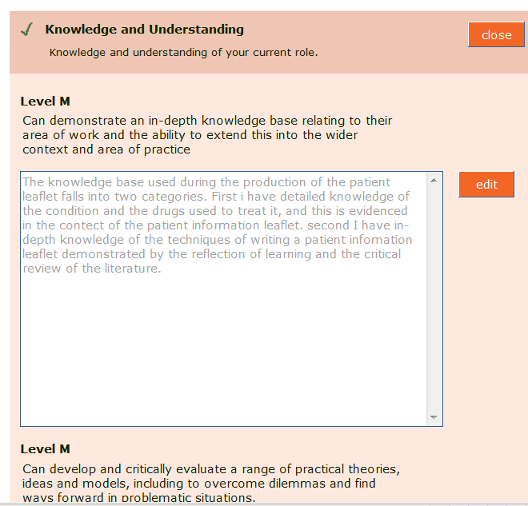
Top Tip
Write this in a word document and then copy and paste it in. This will enable you to use spellcheck and also back up your words in case of computer failure.
You do not have to complete all 11 boxes, and a piece of evidence can be referred to in more than one box. You should go through the sections and the 11 indicators and consider whether the evidence presented shows that they have been met. The evidence that Janice has submitted for example might also meet the indicators concerned with working independently and communication – demonstated by the literature appraisal and the minutes of the meeting.

Reviewing your proposal
The proposal is saved when you press ‘update.’ Navigation can be tricky to start with, but if you are lost, press the ‘learning tab’ at the top

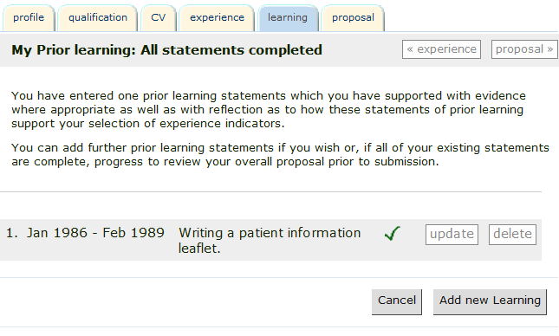
Then press update
And you will get back to this page
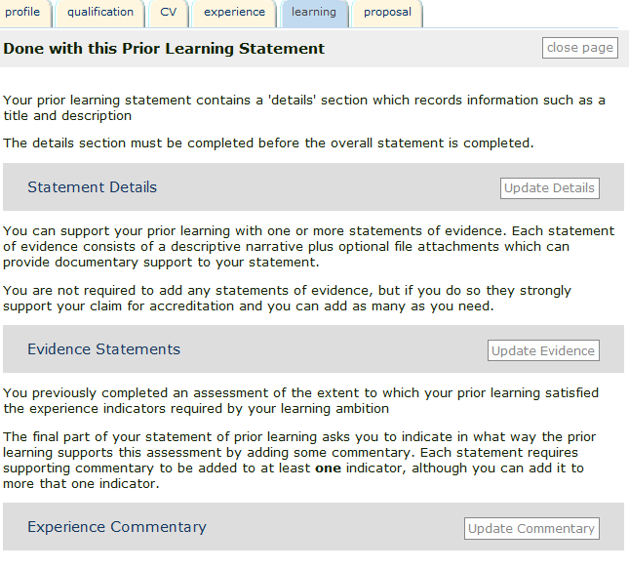
Top Tip
Remember – Each episode of learning needs
Statement details
Evidence
Commentary.
Once you happy that you have completed the sections of the tool you can click on the proposal button which reveals all the details of the claim which can be printed out if you wish. The submit button is at the top.

Formative Feedback
After you have submitted the proposal you will receive some detailed feedback which will offer suggestins about how the work can be improved, and will also identify if the submission will not be succesful. You can expect to receive this feedback within four weeks.
You will be notified - this needs clarification..

The criteria that must be met and how we assess them
Criteria | What this means
Relevance - Previous learning must have relevance to the rest of the learning contract and must be at an appropriate academic level. In an LTW programme the level of the prior learning will be judged by reference to the level indicators for LTW programmes; the relevance of the learning will be judged by reference to the totality of the learning contract. | The outcomes that you have used are the statements that you have ticked in the experience section. It must be clear that the evidence presented does illustrate the learning that you are saying it does, and it is at the correct academic level. The University marking grids for undergraduate and postgraduate levels are at these links.
Sufficiency - Your submission for recognition of prior learning must be adequately and appropriately evidenced. In other words, you must provide sufficient evidence to support the case you are making and to satisfy the assessors that you have made an adequate case for them to grant credit | A 20 credit module is notionally equivalent to 200 hours study, and the Evidencing Work Based Learning modules require a project equivalent to 4000 words at the correct level, and we judge claims compared with this. It’s not just word count though – it is relatively easy to write 10,000 words of (for example) a descriptive diary entry, so we assess the level of the evidence and the amount together.
Currency - Your prior learning must still be meaningful in the area in which the learning has taken place. In other words, it must be up-to-date and reflect contemporary thinking, knowledge and ideas in its field. It must also be sufficiently recent for you to be able to continue to use, understand and remember it. The maximum cut off for prior learning claims is normally five years and each case must be treated on its merits as in some fields, information and concepts date more quickly than in others. | If you have uploaded, for example, a student information pack that you wrote seven years ago, it will need to be accompanied by an account of how the knowledge that you used has been kept updated. This could mean an explanation of how knowledge has changed since you wrote it. If you are submitting, for example, a literature review you will have to demonstrate that this has been recently updated.
Reliability The evidence you present in support of your submission must be such that the assessor feels it would be generally accepted by other assessors in the field. | This means that in the final assessment that the evidence will be marked by two academics independently and may also be reviewed by an external examiner from another University.
Authenticity - The evidence to support your submission must leave the assessor in no doubt that you have achieved the learning you are claiming. | As in writing academic essays it is an assessment offence if you claim others work as your own. When you make the claim you are stating that the work is your own. If there is jointly authored work, a published paper for example, you will need to supply evidence verified by co-authors which states the percentage of the work which is your contribution.

Frequently asked questions
What evidence is required?
You are encouraged to think widely about what evidence to submit – there are many ways that you can show your learning and your skills. You cannot use anything that has been previously submitted for academic credit at UWE or elsewhere. When your claim is considered the assessor needs to see engagement at the correct academic level – illustrated by your assessment of the learning
Type of evidence | Things to consider
PowerPoint Presentations | Problem The slides you present may be information giving. Perhaps your session was delivered to HealthCare Assistants or even children. Suggestion. If you want to claim M level credit perhaps you can engage with or critique the evidence that has determined the way in which you have delivered the session. Or perhaps you can explain how you answered a complex question, or evaluated the session.
Testimonials | Problem Testimonials may not go into details about how you did the thing that was appreciated, but they do give interesting insight into a valuable point of view. Suggestion perhaps you could give some background information and analysis about the situation and how you solved a complex problem. Or relate the perceptions in the testimonial to the published literature.
Lecture handouts | Problem Perhaps the lecture handouts are information giving rather than analytical Suggestion similar to the PowerPoint evidence you might want to upload further evidence which explains the context, or how you decided to take a particular approach to the session
E mails to demonstrate communication skills | Problem They may not demonstrate the skills at the proper level Solution You may want to consider uploading further evidence to show why you wrote in the way you did.

Don’t assume that the evidence is self explanatory – it may need to a supplemented by further evidence which explains your thinking. The higher the academic level the more likely that this is required.
Do I have to provide evidence for all of the statements?
No. these are programme level outcomes which means that they have to be met for the Award rather than each module. You can map your learning against the statements which are relevant. It may also help you to understand what learning you have undertaken if you start at the statements and ask yourself what evidence you can provide to demonstrate that you are able to perform them.

What if I haven’t uploaded enough evidence?
You will be told this when you submit your claim for formative feedback. If you don’t add to it, you will not pass the housing module at the summative assessment stage.
What if I have uploaded too much evidence?
You will be told this at formative assessment. You can either remove some evidence to preserve it for later use (you can’t present the same evidence for two claims). You are advised to have a discussion with the module leader before application for the module. It might be that you can apply for a larger module, but of course this will cost more.
Do I get access to the library?
In order to get access to the library you’ll need to be registered as a current student with the University. If this claim is part of the SHELL awards you should already be registered. If you are using eAEL to claim credit for another award, you may or may not be enrolled. It depends on whether you are doing any other modules. If you are not doing any other modules then you won’t get access to the library until you have registered and paid for the EWBL module.
How much evidence is needed?
This is not as easy to explain as you might think. In order to convert the uploaded evidence to academic credit, regulations about level and time need to be satisfied. Normally modules do this by setting an assessment task, which, it can be claimed meets the outcomes and satisfies regulations. The assessments for the EWBL modules which will ‘house’ your credit are
Credit rating | Assessment
5 credits | Equivalent to a project of 1500 words
10 credits | Equivalent to a project of 2000 words
15 credits
20 credits | Equivalent to a project of 4000 words
30 credits
40 credits | Equivalent to a project of 8000 words
45 credits
60 credits | Equivalent to a project of 12000 words

The word ‘equivalent’ here is helpful because it allows a wide range of evidence, but unhelpful because it doesn’t detail how much.
Your assessor will make a judgement about the amount of evidence required and communicate this to you in the comments box at the formative assessment stage
What if I can’t upload evidence because the file size too big?
Discuss this with your named contact. If it is vital that the evidence is presented it can be submitted in other formats. An example might be a video recording or audio file of a presentation that you have given. It might be e mailed to cpdcredit@uwe.ac.uk with a clear covering letter, or perhaps another format, eg memory stick can be used, but you’d need to get advice about where to send this from cpdcredit@uwe.ac.uk and you’ll need to upload a word document detailing the format of the evidence and where you have sent it.
What happens after I submit the evidence
When you have submitted the evidence you will need to send an email to cpdcredit@uwe.ac.uk to conform that this has been done. The assessor can access your claim and annotate it. At this stage the purpose of the feedback is to give you an indication of whether it is appropriate to the level of claim that you have indicated and whether there is enough evidence. You may get detailed feedback on one or two pieces of evidence. When you have formative feedback during an orthodox module run you would not get detailed feedback on the whole assignment, and neither do you here.
You will be e mailed when the evidence is annotated.
When do I pay?
You do have access to the tool and can upload evidence to it before you pay, but you won’t be able to get access to academic staff, or the library, or get feedback until you have registered with the University and paid the fees. How you do that depends on whether you are enrolled on the SHELL framework or are using the eAEL within a different programme of study.
If you are on the SHELL framework, you will have identified the credits required through the Negotiated Learning Plan, and you will have access to UWE resources through this.
If you are using eAEL through another programme, you will need to enrol on an Evidence Work Based Learning module of the appropriate size and level. When you have done this, and paid the module fee, you will have access to UWE on line resources, and you will also need to set a final submission date with the module leader.
Do I get a mark?
Yes. The evidence that you have submitted form the assessment for an Evidencing Work Based Learning (EWBL) module. This will be marked and the marked will go through the usual examination boards, including review by an external examiner.

