University Research Ethics Committee Guidance Document 1

The use of ‘social media’ in research:
Some questions for researchers and reviewers of research ethics applications.

Introduction

This short paper is designed to inform researchers’ and reviewers of research ethics applications about some of the potential ethical implications and problems that may arise from the use of social media in research. For the purposes of the paper we adopt a broad definition of social media, encompassing a range of different platforms and networks. We take the term social media (sometimes referred to as Web 2.0) as an umbrella label that covers a broad range of internet and web-based sites and services that connect individuals and groups (some free, others more commercial), for example Facebook, Twitter, Flickr and Linked-In.

What connects these disparate worlds is that they connect individuals and involve ‘interaction’ both with the website itself and other visitors. This communication can be concurrent, e.g. text, voice, video-link (synchronous) or the interaction can take place a different times, e.g. by email (asynchronous), it may involve public and/or private interaction between individuals and groups, raising issues such as whether an exchange might then become available to others through retention of data. Several interesting but not unproblematic attempts have been made to classify social media (see the social media landscape diagram below and appendices 1 & 2). Because of the often fleeting existence of platforms, the speed of new innovations and the turnover of sites, we have decided to adopt a thematic approach, using some of the main aspects considered in the ethics elements of research applications to structure out thinking.

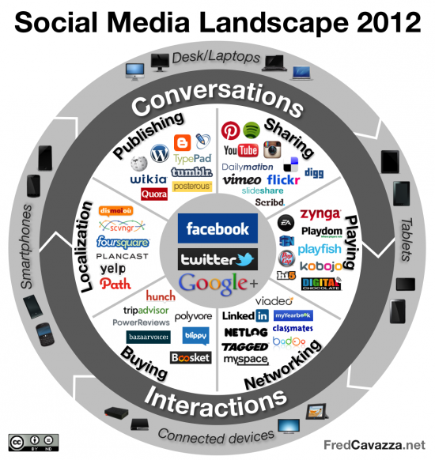

We do not make any judgement about the methodological advantages and disadvantages of deploying social media rather than more ‘traditional’ research tools. Of course there may be benefits such as accessibility, responsiveness, speed, cost, and efficiency; disadvantages may arise around lack of researcher control, lack of face-to-face dynamics, and the exclusion of certain types of potential participants. From a research ethics perspective we see no particular barrier to deploying social media in research; what is important is that any ethical issues are clearly recognised and seriously addressed.

Key Ethical Questions:

We offer the following questions as indicating some of the issues that researchers intending to use social media may wish to consider and which should be addressed in any application for ethical approval.

- Place, Platform & Time
- Where is the research to take place? And when?
- Are there any ethics considerations arising from choice and nature of the platforms?
- Is the research co-terminus with the interaction (e.g. a form of action research)?

- Informed Consent

- How is informed consent to be given?
- Can ‘tacit consent’ be assumed, e.g. from the fact of participation?
- How are participants to be made aware that they are involved in academic research?
- Will there be a ‘participant information sheet’? If so, how will it be provided?
- How can participants withdraw from the research? Can their contributions be removed and/or returned to them?

- Confidentiality & Privacy
- If desired, can the identity or plural identities (‘physical’ or virtual) of research participants be kept confidential?
- Will it be possible to guarantee privacy?
- Is it possible to maintain a distinction between ‘private’ and ‘public’ spaces?
- What are the implications of differences in context between physical and virtual worlds?
- How ‘traceable’ is the data by non-researchers and non-participants?
- Are there any potential dangers from the potential linking (or disaggregation) of data sets by others?

- Transparency/covert research

- Is the research designed to be publicly transparent?
- If covert research is used, how can this be justified?
- Will the researcher adopt a pseudonym or ‘alternative identity’ (e.g. an avatar)?
- Is deception justifiable?

- Anonymity & Authenticity

- If required, will it be possible to guarantee anonymity to research participants (names and contact addresses)?
- Is interaction between participants possible ‘outside’ of the research setting?
- Might it be possible for somebody to participate in research in order to identify individuals for contact outside of that context?
- Can the identity and social characteristics (age, gender etc) of research participants be verified?
- Can ‘direct’ quotations be used and approved?
- How can the contribution of research participants be properly acknowledged?

- Protection of participants

- Are there any risks for participants?
- Will it be possible to protect vulnerable participants and how will this be done?
- Can vulnerable participants be identified?
- How are child participants protected?

- Data management/storage/security
- Will the contributions of research participants be shared?
- What are the implications of the research design for data storage and security?

- Protection of researcher

- Are there any potential risks to the safety of the researcher?
- How can risks be minimised?

- Copyright and right to access

- Who owns the information?
- Can owners of platforms retain data?
- Is there a need to protect research findings or are these to be publicly accessible?
- Can the researcher control the data and the dissemination of findings.
- Is it envisaged that conference presentations might be immediately disseminated through photo sharing and tweeting using the conference hash tag? See for example http://www.guardian.co.uk/higher-education-network/blog/2012/oct/03/ethics-live-tweeting-academic-conferences

Bibliography and Additional Sources:

British Medical Association (2011), Using Social media: practical and ethical guidance for doctors and medical students. BMA publications London
Available at: http://bma.org.uk/practical-support-at-work/ethics/ethics-a-to-z

British Psychological Society (2007), Conducting research on the internet: Guidelines for ethics practice in psychological research online. Available from:
http://www.bps.org.uk/publications/policy-guidelines/research-guidelines-policy-documents/research-guidelines-policy-docum

Ess, C. & and the AoIR ethics working committee (2002), Ethical decision-making and Internet research: Recommendations from the aoir ethics working committee, approved by AoIR, November 27, 2002. Available online: www.aoir.org/reports/ethics.pdf

Kaplan, A. M. & Haenlein, M. (2010) ‘Users of the world, unite! The challenges and opportunities of Social Media’, Business Horizons 53 (1): 59–68.
http://www.sciencedirect.com/science/article/pii/S0007681309001232

Research Information Network (2011), Social Media: A guide for researchers
Available at: http://www.rin.ac.uk/our-work/communicating-and-disseminating-research/social-media-guide-researchers

Snee, H. (2008), Web 2.0 as a social science research tool. The British Library/ESRC Government Placement Scheme
Available at: http://www.bl.uk/reshelp/bldept/socsci/socint/web2/web2.pdf

Prepared by a UREC working group
August 2013

