**Equality Analysis**

This form enables you to reflect on your proposed activity, and to assess the potential positive and negative impacts it might have on different members of our community. The Equality Analysis is designed to help you ensure your activities are meaningfully considered and not spending your time on an activity that will later need to be changed or disbanded due to not thinking about the practical needs of diverse communities. If you have any questions about how to complete this Equality Analysis, please read the [Guidance](mailto:Guidance) or contact the Equality and Diversity Unit: [EqualityandDiversityUnit@uwe.ac.uk](mailto:EqualityandDiversityUnit@uwe.ac.uk).

1. Summary

|  |  |
| --- | --- |
| Activity Title | Academic Roles and Career Structures Project |
| Project manager & contact | Andrea Barnes |

1. Proposed activity (change, refresh, policy, process or practice) being analysed

The project aims to deliver the following:

* Equal value career pathways in Learning and Teaching, Knowledge Exchange and Engagement alongside Research;
* Roles designed to meet current and future needs and aspirations;
* Investment in early career academics as well as career advancement opportunities to professorial level;
* Recognition and reward for pivotal and business critical academic leadership roles;
* Better utilisation of full range of academic roles and grades to help improve cost effectiveness and performance capability at all levels.

The project is sponsored by two strategic programmes, People and Performance 2020 and Learning 2020. The following actions have been identified as priority actions to be delivered collectively as a whole.

1. Establish a visible and distinct career pathways to enable lateral and vertical career advancement
2. Introduce internal promotion opportunity to apply for Associate Professor and Professor
3. Launch two new entrant schemes (Graduate Tutor and Associate Support Lecturer, currently run as pilot)
4. Update academic job descriptions to meet current and future University aims and fit the new career pathways
5. The salaries of H grade programme leaders who are currently paid below H grade bar to be repositioned to above the bar at salary scale point 40.
6. Allow module leadership to be undertaken at a Lecturer level
7. Introduce a tailored development programme for staff new to module and programme leadership

Further information can be found in the Appendix.

1. What sources of information/data, or who have you identified to help explore potential equalities outcomes?

Staffing Statistics, Student or Staff Networks, Specific stakeholders, Athena Swan submission/data, Staff survey, Exit questionnaires, staff recruitment data

|  |  |  |
| --- | --- | --- |
| 1. **Scoping for consultation** | | |
| Does this Equality Analysis require consultation within 3 or 6 weeks (chart to help you decide here) | 6weeks | 6weeks |

|  |  |  |  |  |  |  |  |
| --- | --- | --- | --- | --- | --- | --- | --- |
| **5. Assessing the activity from different perspectives** | | | | | | |  |
| Might your proposal impact people who identify with the protected groups[1] below in the following contexts?   * Staff experience, career advancement/promotion and recruitment and selection   Explain why you have made that assessment, and plan your response.  **Please feed information from this action plan to your project’s own planning documents** e.g. action plans, risk registers, benefits maps | | | | | | | |
|  | | **Possible Impact on Groups** including possible positive and negative outcomes[2] | **Action Planning**: how will you maximise positive and mitigate negative outcomes? | | | | |
| **Actions Required** | **Responsible Person** | **Target date** | **Success indicators** | **Progress to date** |
| **All** (possible impacts affecting many groups) | 1 | (+) The intention is to place equal value and parity of esteem on learning and teaching, knowledge exchange/external engagement alongside research in our career structure, and this has the potential to recognise and value talent from the widest pool of staff.  (+) Currently module leadership is aliged to Senior Lecturer role (H grade). By extending module leadership at a lecturer level, there is scope to increase the recruitment activitiy at this grade, which has a potential to positively impact the diversity of academic workforce and build a talent pipeline to senior lecturer. BME representation is much higher in lecturer (22%) than senior lecturer (10%).  (+) Clear and timely communications of new initiatives and opportunities help decrease stress for all groups._  (-) Increased responsibilities of inexperienced staff could lead to stress and/or performance issues.  **Priority actions A, B, D, F** | 1a) Designing an academic career structure where there are visible career tracks for Learning & Teaching, Knowledge Exchange, Research (Athena Swan action 20). | Andrea Barnes (Project lead) | Dec ‘18 | Implementation of career pathways which ensure academic strengths (whether in research, teaching, KE and leadership) |  |
| 1b) New job descriptions developed to articulate the new career pathways, and designed to ensure inclusivity (e.g. job share/flexible working arrangements being explicit where applicable). |
| 1c) All progression and development opportunities and processes to be visible and accessible on the intranet site, with appropriate links to and from the CPD framework, Learning & Development, Academic Practice, UKPSF, HEA accreditation, Mentoring opportunities. This will be also followed by a continued and targeted promotion, especially to underrepresented groups. |
| 1d) Monitoring of the recruitment and promotion data alongside workforce planning to ensure that candidate pools are attracting the wide cohort and to spot any differential outcomes for equality groups (also this is linked to 2d) | HR Resourcing Manager  Staffing statistics | Ongoing | Diverse demographics represented in all career pathways (aspirational) |  |
|  | 1e) Module leadership will be allocated based on individual capability and readiness to take on the role and supported by a mentor and development workshop.. There will safeguards put in place for module leader allocation, these include completion of probation or 2 years HE experience in learning and teaching. | Line manager | Ongoing |  |  |
| 2 | (-) Athena Swan findings highlighted that the current progression/promotion infrastructure is not clear to staff or to managers, and that practices vary across faculties and departments which has added to negative perceptions of the system.  Consequences for equality group could be a lack of awareness of what is necessary to progress, and therefore self or implicitly excluded.  **Priority actions A, B** | 2a) Priority action B aims to design clear and transparent processes and criteria for promotion to Associate Professor and Professorial roles (Athena Swan action 17). | Andrea Barnes (Project lead)  2a) Athena Swan action 17 – Pam Fitzsimmons (HR/OD)  2c) Athena Swan Action – Departmental leads / Pam Fitzsimmons (HR/OD) | Dec ‘18 | Staff report greater clarity around career promotion in surveys  Open and transparent promotion processes measured through staff survey and feedback from panels, applicants, managers / HR BP’s. |  |
| 2b) Full guidance (intranet) will provide clarity on processes. Ensure that there is effective communication instigated centrally and locally to achieve maximum awareness of the scheme (Athena Swan action 17). |
| 2c At all stages, the project will continue to consider the implications for different equality groups and seek to understand the barriers and challenges facing equality groups, with the aim to minimise these barriers as much as possible (Athena Swan action 8) |
| 2d) Ensure that there is monitoring of the data to review and put in place actions to improve applications from equality groups. |
| 2e) Promotion panels and HR Business Partners will be fully trained in the new promotion scheme, process, criteria and assessment. | Panels members and HRBP’s | Dec ‘18 | Panels are confident in their role and the outcomes |  |
| 2f) Faculty panel will be responsible for shortlisting applicants against a promotion criteria – with HR Business Partners providing advice and guidance, as well as ensuring equability of assessment.  Decisions made at faculty level will be calibrated at university level for equitability and consistency purposes (in relation to assessment/judgements at local level). | Faculty Panels and HRBP’s | Dec ‘18 | See above. |  |
| 2g) Panel compositions to achieve gender balance (and if possible BME representation). | Panel chairs | Dec ‘18 |  |  |
| 2g) Feedback will be provided to applicants after shortlisting and interview stages. This will need to be meaningful and supportive, ensuring those unsuccessful in the process have a clear understanding of areas for development and what support is available to help them progress. | Faculty and university chairs (or nominees) |  |  |  |
| 3 | (-) Any element where there is discretion in making selection decisions can be highly vulnerable to bias.  **Priority actions A, B, C** | 3a) Unconscious bias training is now available to all recruiting managers. Ensure that those participating on promotion panels are fully trained (Athena Swan Action 15). Additionally training in the responsible use of research metrics will be given to panel members. | Panels | As and when | Panels fully trained. |  |
| 4 | (+/-) Experience of PDR is varied. 83% of faculty staff received a PDR in 2017. By faculty, ACE 72%, FBL 67%, FET 91% and HAS 92%.  **Priority actions A, B, C, D, E, F, G** | 4a) The new PDR process should create improved opportunities for a dialogue about career aspirations and analysis of individual development needs.  The PDR guidance will be updated to make an explicit reference to promotion and development opportunities and this will be reflected in future briefings and training. | PDR reviewers | Dec ‘18 | PDR conversation are meaningful (staff survey)  Increased awareness of promotion and development opportunities |  |
| **Age** | 5 | (+) The average of a UWE employee is 44 years. 55 years and over accounts for 24% of the workforce. The largest population at SL and AP level is 45-54 years.  (-) Older applicants may not have a plan to contribute over a 3 year and this could work to discourage applications.  **Priority action B** | 5a) An individual will be expected to demonstrate their planned and potential to contribute over a 3 year period. The scheme will allow for an adjustment to this period should an individual have planned and confirmed their intention to retire within this period. | Andrea Barnes (Project lead) | Dec ‘18 | Applications received from across the age range. |  |
| 6 | (-) Using length of service as a criterion for determining promotion or progression is potentially discriminatory to younger people.  **Priority action B** | 6a) The criteria will ask for an individual to demonstrate their achievements and contributions over the past 3 to 5 years, however length of service will not be a requiste for determining promotion.  Also see 7a). | Dec ‘18 |  |
|  |  | (+) New entrant schems will likely to attract younger aspiring academics as an entry point to academic career.  **Priority action C** |  |  |  |  |
| **Disability**, including mental health and non-visible disabilities | 7 | (-) Disabled staff may be less able to take advantage of career development opportunities due to time off for appointments. Staff with a declared disability is 5.6% of the UWE workforce, with slightly less at Senior Lecturer and Associate Professor level (5%), dropping considerably at Professor level (1.2%). This could be an issue of non disclosure as well as lack of career progression for this equality group.  **Priority actions A, B, G** | 7a) The application process will allow for individual’s to draw attention to any particular personal or relevant circumstances that may have impacted on their work for a defined period of time.  Panels will be made of aware of these issues through briefing and guidance to ensure that these individuals are not disadvantaged. | Dec ‘18 | Increase in declared disability at professoral level (aspirational) |  |
| 8 | (-) Disabled staff may have reasonable adjustments which need to be taken into account when accessing information and the application system and/or assessing against a criteria for promotion / progression.  **Priority actions B, D** | 8a) Promotion criteria and processes will be developed with flexibility to accommodate reasonable adjustments and different working patterns/hours. Should there be any barriers in terms of process or system, a different format of applicationform will be provided.  For example, if we include a graphic on an intranet page that describes new career paths, we need the graphic to be readable by a screen reader, or we need to include text which explains the information conveyed by the graphic, so a person with a severe visual impairment can understand what’s happening. | Dec ‘18 |  |  |
| 9 | (-) Using length of service as a criterion for determining promotion or progression is potentially discriminatory to disabled people as they may have an extended period of absence due to disability.  **Priority action B** | 9a) See 6a and 7a |  |  |  |  |
| **Women and men** | 10 | (+) The opening up of a learning and teaching career track could have the potential for recruiting and promoting more women into senior academic leadership roles i.e. Associate Professor / Professor roles.  **Priority actions A, B, C** | 10a) Workshops on career pathways and progression will be developed and available for all staff. These will be evaluated and the demographics of the uptake of the workshops to be analysed (Athena Swan action 18). | Andrea Barnes / Liz Cleaver / Helen King (Academic Practice Directorate) | Dec ‘18 | Increase the proportion of female applicants and appointments. |  |
| 10b) Profiles/case studies of those who are successfully achieving at AP and Prof level – particularly in L&T and KE domains – will be included in workshops and intranet (Athena Swan 29). |
| 11 | (-) Women are typically less likely to apply for promotion or additional responsibilities than men. ECU 2016 54% are women and under represented in the highest contract levels and over represented in the lowest. At UWE, 59% of the workforce are women, 44% are at AP level and 36% at Professorial level.  **Priority actions B, E, F** | 11a) Job descriptions to be developed with inclusive language – to attract more female applicants (Athena Swan 16). | Andrea Barnes (Project lead) | Dec ‘18 |  |
| 11b) See 7a and 8a for different working patterns/part time working. | Dec ‘18 |  |
| 11c) Access to mentoring schemes will support staff seeking promotion (in particularly women in research mentoring, Academic Professional Apprenticeship Scheme (where mentors play a bigger role) (Athena Swan 19). | Pam Fitzsmmons (HR/OD) | Dec ‘18 |  |
| 12 | (-) Some elements of the promotion criteria and module/programme leadership may be more difficult to achieve on part time hours.  **Priority actions B, E, F** | 12a) Promotion panels will recognise that the quanity of work will be reflective of the fractional hours worked.  Module/programme leadership workload allocation is based on the role and not contractural allocation. | Panel members  Line managers | Dec ‘18 |  |
| 13 | (-) Those with caring responsibilities, or staff returning from leave such as maternity, adoption, ill health may be less able to access career development opportunities.  (-) Using length of service as a criterion for determining promotion or progression is potentially discriminatory to women as they are more likely to take on caring responsibitlies and may have an extended period of absence or career break.  **Priority actions B** | 13a) See 7a for personal circumstances. | Andrea Barnes (Project lead0 | Dec ‘18 |  |
| 13b) See 6a and 7a |  |  |  |  |
| 14 | (+) There is a scope for part time working within the new entrant schemes, subject to ensuring that the successful completion of the scheme remains viable. Each case will be considered on its merits.  **Priority action C** | This will be clear in Frequently Asked Questions on the staff intranet site. |  |  |  |  |
| **Trans and non-binary people**, including gender reassignment | 15 | Not known at UWE. In Stonewall “LGBT in Britain work report (2017)” 24% of trans employees say they didn’t get promotion because of being trans.  **Priority action B** | 15a) See 7a for personal circumstances | Andrea Barnes (Project lead) | Dec ‘18 |  |  |
| 15b) See 8a for different working patterns. | Dec ‘18 |  |  |
|  | 16 | (-) Using length of service as a criterion for determining promotion or progression is potentially discriminatory to trans people as they may have an extended period of absence due to transition.  **Priority action B** | 16a) See 6a and 7a |  |  |  |  |
| **Marriage** and/or **civil partnership** | 17 | Not known | No implications identified. |  |  |  |  |
| **Pregnancy** and/or **maternity**, including Adoption | 18 | (-) There could be a perception that maternity/adoption leave may negatively impact ability to apply for promotion or new entrant schemes.  **Priority actions B, C** | 18a) The promotion criteria will be based on individual’s providing evidence of achievement and contribution over a 3-5 year period. The scheme will allow for adjustments to this period to be made for period of leave such as maternity/paternity, adoption. | Andrea Barnes (Project lead) | Dec ‘18 |  |  |
| 18b) New entrants scheme are for a fixed period. We intend to extend this period for those taking maternity/adoption leave. |  |  |  |
| **Race**, including ethnicity and citizenship | 19 | (-) ECU 2016 note BME staff were under represented in the highest contract levels and over represented at the lowest. BME staff account for 9.6% of the UWE workforce (2017), with 10.5% at Senior Lecturer, 8.8% at Associate Professor and 9.3% at Professorial level. This group tend to be less successful at securing career development or progression opportunities.  **Priority action B** | 19a) See 4a,10a,10b,11c | Andrea Barnes (Project lead)  Pam Fitzsimmons (HR/OD) | Dec ‘18 | Applications from BME staff are proportional to workforce. |  |
| **Religion and/or belief**, | 18 | 33% of UWE’s workforce declared as having a religion or belief (2017) but the impact is unknown. | No implications identified. |  |  |  |  |
| **Sexual orientation** | 19 | 4.7% of UWE’s workforce declared as lesbian, gay or bisexual (2017). In staff survey, experience of PDR is slightly more negative for this group comparied to a hetrosexual cohort.  **Priority actions A, B, C, D, E, F, G** | 19a) See 4a, 10a, 10b, 11c |  |  |  |  |
| **Other specific group** | 20 | No other group identified as being impacted. | No implications identified. |  |  |  |  |

|  |  |  |  |  |  |
| --- | --- | --- | --- | --- | --- |
| **6. Next Steps:** |  | | *Delete or complete as appropriate* | | |
| Is further monitoring or engagement required? (additional to the formal Equality Analysis consultation) | |  | | Yes |  |
| What measure / statistic / data will you use to check if the activity has had a positive, negative or neutral outcome? | Equality data on applicants and successful candidates for all initiatives*.* Survey of staff experiences (e.g. applicants, workshop participants, new entrant scheme participants, Module Leaders). | | | | |
| When will you review this Equality Analysis? | Immediately after the operation of the scheme in it’s first year. | | | | |

7. Equality and Diversity Unit Recommendation

**The outcome of the Equality Analysis is (Place ‘X’ in corresponding box):**

|  |  |
| --- | --- |
| No major change: the proposal is neutral or positively promoting equality and diversity at UWE |  |
| Some adjustments required: there are or potentially were some negative outcomes and the proposal has been adjusted to reflect these additional considerations |  |
| Considered impacts are legally justified: there are no further mitigating measures that can be applied, the impact is an a result of legal requirements. The risks have been investigated and considered by the appropriate stakeholders and there is no risk of unlawful discrimination. Further details are included in the Analysis. |  |
| Stop and removal of policy: the potential negative outcomes of the proposal can not be legally justified or mitigated for and/ or there is a risk of unlawful discrimination |  |

|  |  |
| --- | --- |
| Equality and Diversity Unit Representative |  |
| Date |  |

8. So what?

Consultation and engagement feedback is extremely important in Equality Analysis. Listening to student and staff voices and acting on their feedback mean that activities become fit for purpose for diverse student and staff communities. Complete the ‘You Said, We Did’ table before and after formal consultation, and throughout the remaining lifetime of your activity to show the impact of feedback on your activity. The Equality and Diversity Unit will be in touch to gather examples of this feedback to share with equality stakeholders.

|  |  |
| --- | --- |
| **You said** | **We did** |
|  |  |
|  |  |

9. University Sign off

I am satisfied with the results from investigation, consultation and analysis. The progression of this EA will continue to throughout the activity/project and I will ensure that a review is undertaken following the final implementation of the proposal, to assess its actual impact. Any actions or feedback that results as a consequence of ongoing project changes will be monitored and incorporated within the stated processes. Any negative outcomes will be resolved with the appropriate stakeholders identified.

|  |  |
| --- | --- |
| Deputy Vice Chancellor |  |
| University |  |
| Date |  |

**Please forward an electronic copy to the E&D Unit by emailing** [**EqualityandDiversityUnit@uwe.ac.uk**](mailto:EqualityandDiversityUnit@uwe.ac.uk)

**The original signed hard copy and/or electronic copy should be kept with your team for equality audit purposes, and progression of information requests, actions and review.**

1. **Protected characteristics** are as identified by the Equality Act 2010 (The “Others” row is an exception to the legal protected characteristics. However, as UWE is interested in providing the best learning and working environment for all our members we encourage active thought for all diversity groups that proposals/activities may effect, for example International students or widening participation groups.
2. A **positive outcome** or impact is where a person or people may experience an advantage or benefit as a result of the proposed change. This includes positive action to overcome a disadvantage, meet different needs or encourage participation. An illustration of this principle could be: increasing lighting in public spaces of campus, which increases personal safety, particularly for people from protected groups. A **negative outcome** or impact is where a person or people may experience a disadvantage compared with others, or compared with what was previously available, or planned. For example a new bus service is set up to help all students travel between campuses, but no drop kerbs or accessible buses are available. Bear in mind that some negative outcomes may be justified on the basis of a legal requirement or applicable exemption including use of positive action or where the outomce would conflict with other legislation, e.g. Health & Safety. If a negative outcome can not be mitigated due to a legal requirement, identify the legislation and considerations you have considered to reduce the negative impact and/or rationale for the decision.

   **Appendix: Academic Roles & Career Structure for Outstanding Learning**

   # Introduction

   UWE Bristol was awarded ‘Gold’ in the Teaching Excellence Framework meaning it delivers consistently outstanding teaching and learning outcomes for its students. The University has also climbed to 37th in the Guardian league table and its overall National Student Survey (NSS) score of 89% places it in the top ten universities in the UK for student satisfaction.

   In order to sustain this outstanding position, it is necessary to ensure that academic staff roles are well defined and that there exists a clear academic career pathway.

   This project was initiated to take a holistic approach to re-shaping our academic career structures and roles so that they align to the strategic goals and values of the University. There are four project objectives as outlined below:

   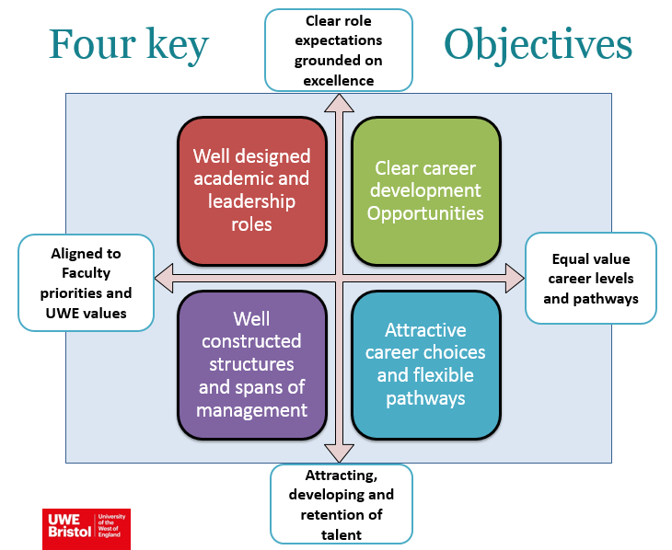

   The overarching drivers for this project are set out below:

   **Teaching excellence and outstanding learning** delivered by inspired, well connected and committed staffis a key strategic Learning 2020 ambition. This project aims to place equal value and esteem on learning and teaching, knowledge exchange and external engagement, alongside research with impact, opening talent pipelines across core academic activities.

   **Changing HE landscape and rapid technological advances** will change future employment, roles and skills, impacting what we teach, the ways we teach and how we interact with each other and our students. Shaping academic roles to meet changing organisational needs, and recruiting and developing individuals to deliver performance excellence are key components of this project.

   **Student demand for high quality and value for money** will continue to grow. Recent research shows that 38% of students think their course offers good value for money, with students prioritising high quality teaching, helpful feedback and good learning resources as factors which demonstrate good value. Maximising talent and building a diverse workforce across the full range of grades and roles will help to improve overall cost effectiveness and performance capability to meet the needs of students and their preferred futures.

   # Design team

   The project is sponsored by two strategic programmes, People and Performance 2020 and Learning 2020. A design team comprising of senior managers participated in a number of workshops during 2017 to co-create our approach to the 4 key project objectives, with input from a wider stakeholder group at various stages of the design work to inform and develop thinking. The actions proposed in this project has full faculty support.

   # Foundation blocks

   A number of **priority actions** have been identified requiring trade union engagement. Each action interconnects and if delivered collectively as a whole set the foundation blocks for future work in support of University’s 2030 strategic aims.

   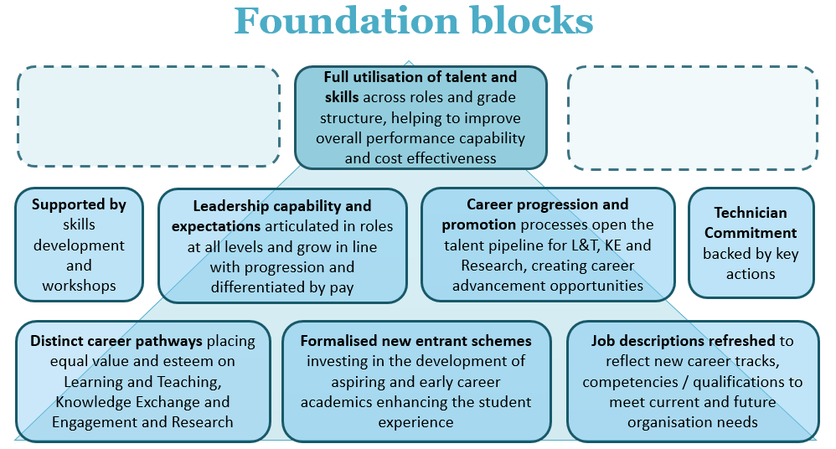

   # Career structure and roles

   Informal discussions with UCU representatives have now concluded and formal consultation will commence on 10 October 2018 for a period of 6 weeks. Action F will be formally negotiated through the University’s Joint Employee Relations Committee.

   Any identified consultative actions resulting from the published [Technician Commitment Action Plan](https://intranet.uwe.ac.uk/about-uwe-bristol/who-we-are/technician-commitment) will be progressed separately with Unison as appropriate.

   ACTION A: VISIBLE and DISTINCT CAREER PATHWAYS

   To enable lateral as well as vertical career advancement on distinct pathways of equal value and esteem (Learning and Teaching, Knowledge Exchange, External Engagement and Innovation, and Research), in support of the University’s strategic ambitions, TEF Gold and Athena Swan commitments.

   ACTION B: OPENING TALENT PIPELINE to Associate Professor and Professor

   To introduce a University led scheme designed to provide an annual opportunity for individuals to apply for promotion to Associate Professor and Professor and do so on an equitable basis. The scheme aims to recognise UWE Bristol’s most talented staff and their outstanding leadership and contributions to the University’s strategic priorities in learning and teaching, research, knowledge exchange, external engagement and innovation.

   This scheme enables career advancement to professorial level on pathways of equal value and esteem, underpinned by strategic alignment and financial sustainability.

   ACTION C: NEW ENTRANTS

   To improve and formalise two new entrant schemes as an established part of the academic career structure. These schemes (currently piloted in FBL and FET) create an excellent early ‘learning ground’ and entry point for individuals looking to take their first step towards a career in lecturing and/or research within the Higher Education sector. Each scheme provides a structured programme of activity and development over a fixed period.

   * The Assistant Support Lecturer scheme is a 3-year traineeship specifically aimed at individuals with an enthusiasm and interest in learning and teaching and enhancing the student experience, and includes the opportunity to acquire a teaching qualification.
   * The Graduate Tutor scheme is a 5-year traineeship (3-year initial contract with an addition 2-year extension dependent on academic progress). It combines completing PhD level research alongside gaining on the job experience in learning and teaching plus a teaching qualification, to enhance our research informed teaching culture.

   ACTION D: JOB DESCRIPTIONS

   To update the bank of existing academic job descriptions to meet current and future University needs, aligning responsibilities to the core academic activities and the new career pathways (including refreshing the Module and Programme Leader role profiles).

   ACTION E: PROGRAMME LEADER

   The salaries of H grade programme leaders who are currently paid below the H grade bar point will be repositioned to above the bar at salary scale point 40 [scale point 40](https://docs.uwe.ac.uk/ou/hr/IntranetContent/Pay%20Scale%20Rate%20for%20Intranet%20Aug%2018.pdf), in recognition of the importance and pivotal role programme leaders play in achieving high student satisfaction and teaching excellence.

   This is based on the principle that a programme leader will typically hold these responsibilities for a minimum of 3 years. Where programme leader responsibilities are relinquished and replaced with equivalent leadership activities, the new salary position will be maintained.

   ACTION F: MODULE LEADER

   To allow module leadership to be undertaken by lecturers as well as senior lecturers. This will enable aspiring lecturers to develop leadership skills earlier in their career within a supportive environment and maximises our ability to utilise talent across the full range of academic roles bringing the University in line with other Alliance Universities who typically set these responsibilities at lecturer as well as senior lecturer level.

   The introduction of module leadership at lecturer level will be supported by specific support, development and safeguards. In the normal way, progression from lecturer to senior lecturer will continue to apply at the progression bar point.

   ACTION G: DEVELOPMENT WORKSHOPS

   To introduce a tailored development programme for staff new to module and programme leadership, equipping them with the skills and knowledge to perform effectively in these critical roles.