Student Guidance for submitting a Stage 2 Complaint

If you are considering submitting a stage two complaint, please first read the additional guidance on the Complaint pages of the UWE website.

The stage two complaint submission should normally only be used after you have attempted to resolve matters informally under Stage One.

If you decide to submit a stage two complaint, you need to do so via this link

Please be aware:

You will need to log in with your UWE login
- It is best to have all details ready before starting the online submission.
- If you have been inactive for more than 10 minutes when completing the form you might lose your details and have to resubmit it. This is due to Browser settings.
- You may find it useful to write your complaint statement in word and have this ready to copy and paste into the form.

Once you have entered your UWE login, you will be presented with the welcome page:

- Click on the Stage Two Complaint button, the following guideline page will appear:

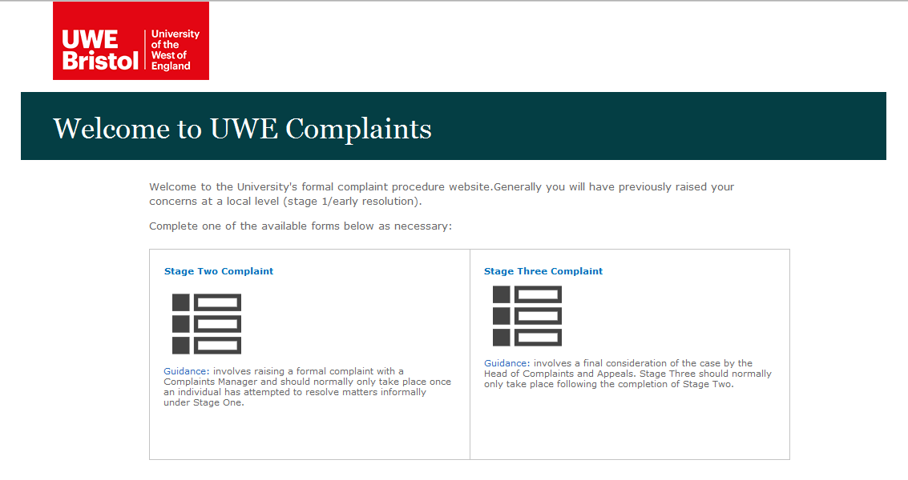

- Please read all the information on the page and then click ‘Next’ to begin.

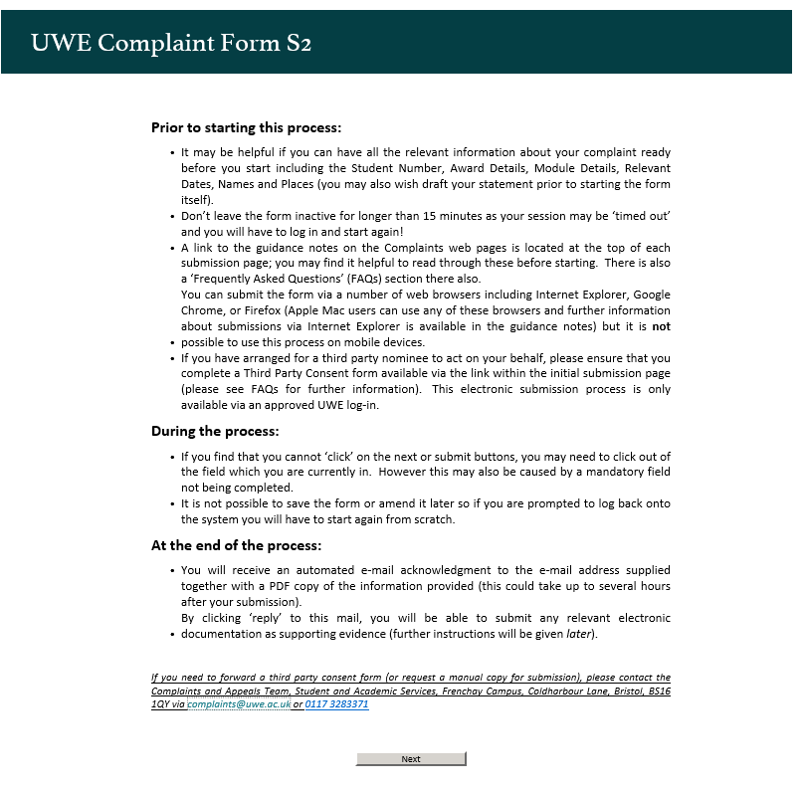

If you have any technical difficulties with online submission, please contact The Complaints and Appeals team at complaints@uwe.ac.uk or +44(0)117 32 83371

Filling in the form

You must fill in all compulsory fields * a red asterisk indicates these.
You cannot move to the next page or submit the form until you have entered all compulsory fields. Unfortunately it is not possible to show a message of what is missing, so please check all the fields on the page if the next or submit button is ‘greyed out’.

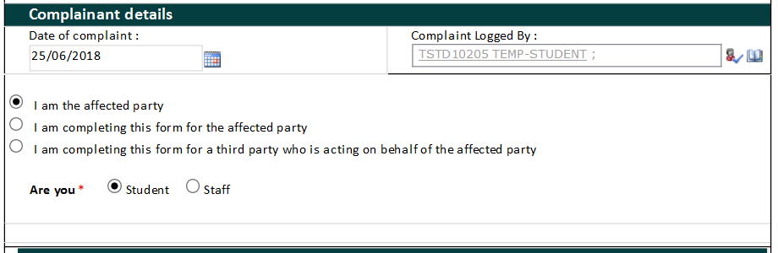

Complainant details

- Today’s date and your login details will be appear automatically at the top of the form.

- You will need to tick the appropriate box to select if you are completing the form for yourself or on behalf of someone else.

- If you are completing the form for yourself, tick the first box to confirm that you are the affected party.

- Tick the box to confirm if you are a student or a member of staff.

- The form will then open with further fields.

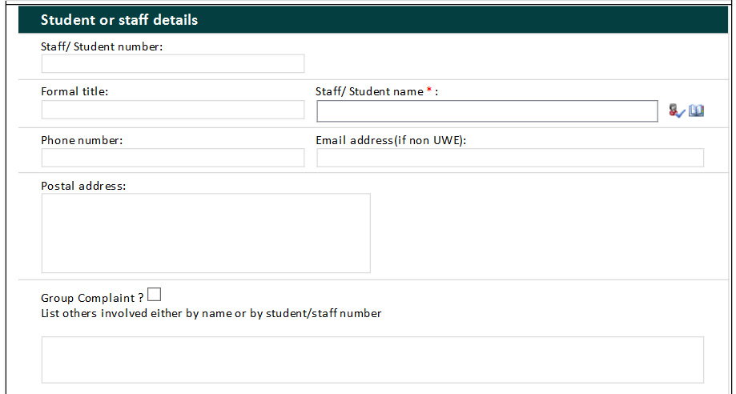

Student or Staff details

- Enter your name as it appears on your student record in the format of first name then surname, for example, John Smith
Then click on the tick icon
If you are unable to find your name, click on the book icon this will bring up a search box, in the ‘Find’ box, type part of your name and click the magnifying glass to search for your name.

- If you would like to supply an alternative email address to your UWE address please put this in the email address box, please leave blank if you are happy to use just your UWE one.

- If you are submitting a group complaint, please tick the group complaint box and list the other student’s names.

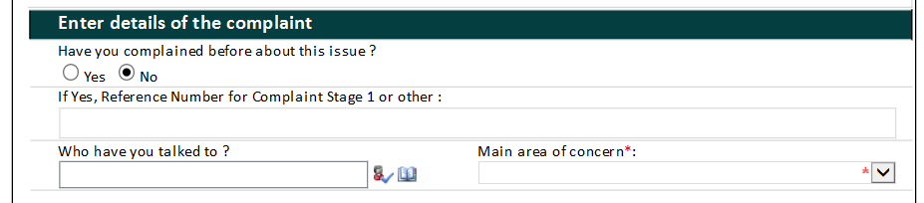

Enter details of the complaint

- Use the top of this section to enter any details on your complaint at stage one, any reference number if you have one, the name of the person with whom you spoke, the main area your complaint covers.

- The next sections allow you to explain the detail of your complaint, steps you have taken to resolve it at stage 1 and the outcome that you are seeking. These boxes will expand as you type. If you are using Internet Explorer your text will automatically wrap as you type into the box, this may not be the case with other internet browsers such as Chrome and Firefox.

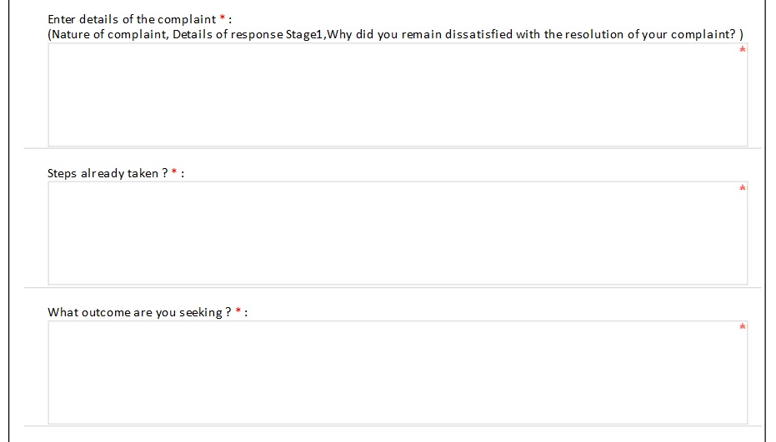

Please read the statement at the bottom of the form regarding the General Data Protection Regulation (GDPR) and tick the box if you agree to the University processing your personal data as described.

- Once you have completed all the compulsory fields and are ready to submit the complaint click on the submit button.

Do not click on the submit button more than once.

If the submit button is ‘greyed out’ this may be because you have not completed all the compulsory fields or because you need to click outside of the last box you were in to enable you to move on.

It can take up to a minute for your complaint to submit. Please look at the browsers activity to check whether any processing is taking place. After a minute you should see the following ‘Thank you’ message.

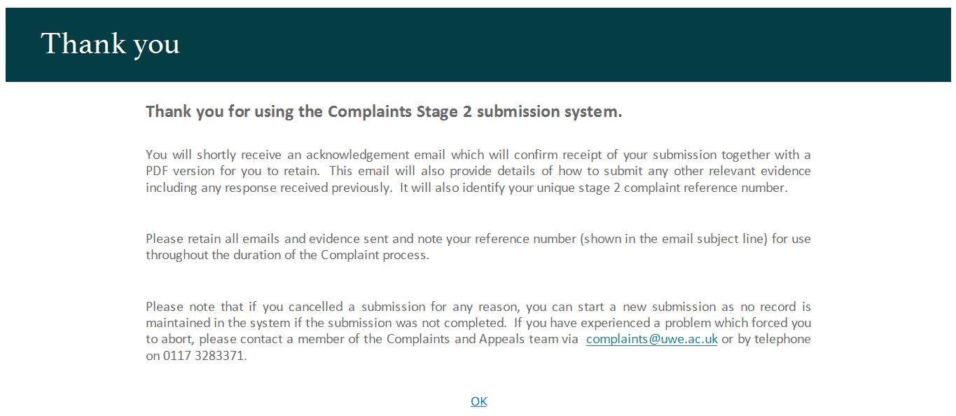

Confirmation email
You will receive an email confirmation of your submission. This will give the complaint reference number in the subject line and will have a pdf copy of your complaint form attached. The PDF copy may not show all the details if you have entered a lot of text in the complaint details section. Please note that the email may take several hours to come through to your inbox.

Submitting Evidence
Please follow the guidance carefully in the email in order to submit any relevant information to accompany your complaint.

Should you have any queries relating to your complaint, please contact the Complaints and Appeals team (quoting your reference number) preferably via complaints@uwe.ac.uk

Next steps
A formal email acknowledging your complaint and confirmation that it will be considered at stage two of the complaints procedure, will be sent to you within 3 workings days of your submission. Subsequently your complaint will be allocated to a Complaints and Appeals Manager and you will be emailed with the name of the Manager and the expected response timescale.

