# Inclusivity 2020 Overview

What is Inclusivity 2020?

Inclusivity 2020 is UWE Bristol’s new Single Equality Scheme containing our **equality objectives** for 2016-2020. The Scheme includes an **Action Plan** with institutional commitment, which **embeds inclusivity** in both strategic and day-to-day activities.

In stating UWE Bristol’s equality objectives for the next four years, this Scheme responds to, and goes beyond, public sector equality duty requirements set out in the **Equality Act 2010**.

What will Inclusivity 2020 achieve?

The overarching equality objectives for the scheme are:

|  |  |
| --- | --- |
| **Student attainment** | each equality group to have as good an outcome as others |
| **Staff perceptions** | each equality group to have as good an outcome as others |
| **Student perceptions** | each equality group to have as good an outcome as others |
| **Student and staff recruitment** | student and staff populations to match the relevant populations for Bristol/UK |
| **Staff and student progression/promotion** | each equality group to have as good an outcome as others |

How was Inclusivity 2020 developed?

UWE Bristol has developed a sector-leading approach, bringing together:

* Key **metrics** describing staff and student journeys;
* Engagement with, and **feedback** from, students and staff; and
* **Clear links** between the action plan, and the key metrics and the feedback.

How will we know if it is working?

Every Inclusivity 2020 objective and action is **linked to key metrics**, many of which also appear in UWE Bristol’s Access Agreement, or in 2020 Strategic Programmes. Progress will be monitored throughout the lifetime of the scheme, and an **impact report** will show the progress made against these metrics.

Actions fall under six **Aims**, collectively known as the ‘**For Alls**’.

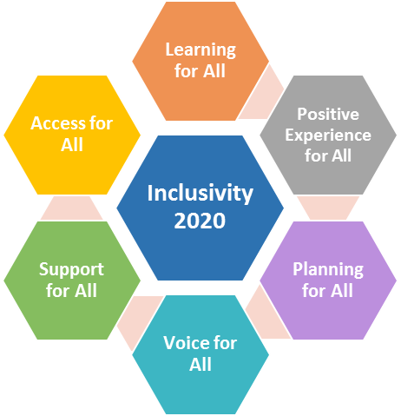

**Support BME, male and disabled student success**

**Improve the experience of, and support for diverse staff and students**

**Ensure we collect and use data to support interventions on behalf of equality groups**

**Ensure that diverse groups of students, staff and Governors inform decision-making**

**Increase accessibility on our campuses**

**Increase the diversity of staff**

Major themes from the Action Plan:

Who monitors the Single Equality Scheme?

Inclusivity 2020 is owned by **Equality Management Group** who monitor it and report on its progress to senior leadership. This group includes representatives from all Faculties and Services and the Students’ Union. The **Equality and Diversity Unit** produce and communicate regular reports on progress.

|  |  |  |  |
| --- | --- | --- | --- |
| What can I do to help?  **Inclusivity 2020** gives UWE Bristol a strong plan to build an even more inclusive university by 2020 by increasing diversity and improving the experience of equality groups.  You can **support action holders** to complete their actions. **Get involved** in a student society or staff network. Or **provide your views** via online consultations or relevant events. |  |  | Where can I find out more?  Inclusivity 2020 can be found on UWE Bristol’s Equality and Diversity website from autumn 2016: [www.uwe.ac.uk/equalityanddiversity](http://www.uwe.ac.uk/equalityanddiversity)  Whom can I contact?  Please contact the Equality and Diversity Unit:   * 0117 32 81719 * [equalityanddiversityunit@uwe.ac.uk](mailto:equalityanddiversityunit@uwe.ac.uk) * @UWEEquality |