Equality analysis form

If the activity you are planning to analyse is covered by an existing Equality Analysis or a relevant former Equality Impact Assessment, please use Section 2 of the form to highlight any updated information. The updated form should be sent through to the Equality and Diversity Unit for feedback, the start of the online consultation process and publication.

Section 1
Equality Analysis Screening

The following questions will identify whether a full Equality Analysis will be required. Please read the Equality Analysis guidance prior to completing the screening.

- Name of the activity (strategy, policy, practice etc)
Nursing and Midwifery (NAM) review. The nursing and midwifery department at UWE, Bristol is a large, and complex, department covering a diverse array of business, which is currently provided across two campuses; one at Glenside and one in Gloucestershire. Over recent years there have been significant changes impacting on the nursing and midwifery profession, the department and, in turn, education. Whilst current management structures have been adapted to respond to these changes it has been recognised that this is becoming increasingly challenging as the structure is currently based on a largely traditional model of nurse and midwifery education. Therefore a review is being carried out of the current structure and working practices to see what changes might be needed in order to support the department in meeting future objectives and responding to external and internal drivers. A number of engagement events have been carried out with all staff in NAM ,with Unions and the management team. The feedback from all of these events has been collated and reviewed and a proposed structure drawn up taking into account all the feedback. This will be shared with the Unions, the faculty executive, the management team of NAM and then staff as part of a formal consultation process.

- Will this activity have the potential to deliver positive outcomes for students, staff and/or visitors from equality groups? Please provide evidence for your answer.
The changes in structure for the department that are being proposed are responding to the rationale below and feedback from staff and students:
- The need for the department to proactively respond to changing external and internal drivers that would ensure the future proofing and success of the department
- An opportunity to pause as a department and consider ways of working and how we want to work together going forward.
- The chance to directly respond to staff feedback from the UWE staff survey , such as transparent decision making, involving staff in decision making, having an open culture, supporting staff development , clear lines of communication and smaller line management teams.
- The ability to streamline decision making and duplication of management responsibilities

There is the potential for positive outcomes for staff and students from all equality groups by ensuring the department structure is fit for purposes to fully support staff and students, by ensuring transparent decision making, staff voice and communication, staff development and smaller line management teams.

- Will this activity have the potential to create negative impacts on students, staff and/or visitors from equality groups? Please provide evidence for your answer.
There is the potential for a negative impact on staff if there is a restructure of the department and possible changes in roles, redeployments, redundancies, etc.

Women, men, transgendered people – Potential impact in terms of redeployment or redundancy, and through role changes, or changes in work patterns which can be more difficult to accommodate in instances where staff – statistically more likely to be female staff - have caring responsibilities.

Transgendered people in organisations can experience negative impact due to moving to a new team, or having a new line manager or different tutor.

Black and minority ethnic groups
No envisaged impact

Disabled people
This staff group would be likely to have existing adjustments pertaining to current roles, and in
any such case these would need to be revisited in relation to any new or revised roles, with a
concomitant need to ensure appropriate disability contact and support structures maintained
during realignment processes.

Younger or older people
Yes in terms of possible relocation, redeployment or redundancy. Also potential different needs in relation to staff training, development and relevant support for new roles, and aspirations; no impact envisaged regarding stakeholders due to nature of changes

People of different religion and beliefs
People with different faiths and beliefs can experience negative impact due to having a new line
manager if arrangements for leave or for periods of fasting are not promptly put in place.

Lesbian, gay and bisexual people
LGB people in organisations can experience negative impact due to moving to a new team, or
having a new line manager or different tutor.

Pregnancy and maternity
People who are on leave can experience negative impact due to uncertainty or change of line
Manager, nobody currently pregnant or on maternity/paternity leave.

Marriage and civil partnership
No envisaged impact

- Does the activity have the potential to impact equality groups in the following ways:
- Access to or participation in UWE Faculties or Professional Services?
- Levels of representation across the UWE workforce?
- Student experience, attainment or withdrawal?
- Staff experience?

Please indicate YES or NO. If the answer is YES then a full analysis must be carried out. If the answer is NO, please provide a justification.
YES

Equality analysis screening sign off:
Faculty Dean or Head of Service | Steve Neill  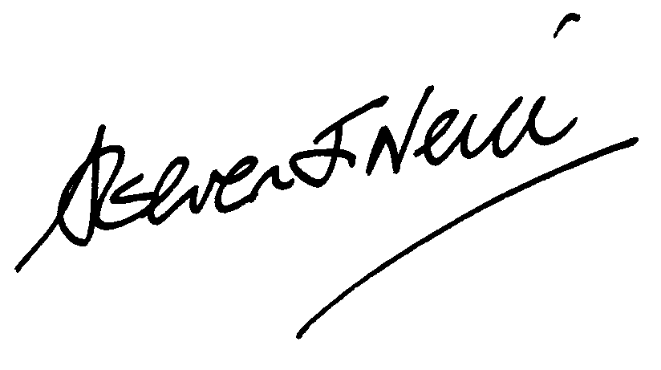
Faculty / service | HAS
Date | Friday, 27 April 2018

Please return the completed form back to the Equality & Diversity Unit for feedback and publication

Section 2
Full Equality Analysis

1. Name of the activity (strategy, policy or practice etc)
Nursing and Midwifery review.

2. What is the aim of the activity (objective or purpose)?
The nursing and midwifery department at UWE, Bristol is a large, and complex, department covering a diverse array of business, which is currently provided across two campuses; one at Glenside and one in Gloucestershire. Over recent years there have been significant changes impacting on the nursing and midwifery professions, the department and, in turn, education. Whilst current management structures have been adapted to respond to these changes it has been recognised that this is becoming increasingly challenging as the structure is currently based on a largely traditional model of nurse and midwifery education. Therefore a review is being carried out of the current structure and working practices to see what changes might be needed in order to support the department in meeting future objectives and responding to external drivers. A number of engagement events have been carried out with all staff in NAM and with Unions and the management team. The feedback from all of these events was then collated and reviewed and a proposed structure drawn up taking into account all the feedback and then will be presented to the Unions, the faculty executive , management team of NAM and then staff as part of a formal consultation process.
The proposed structure could mean that the management team in NAM would be ring-fenced and go through a selection process. There may be the risk of redundancies if people are not successful or do not wish to apply for roles, or there may be changes to grades or roles through redeployment processes. We do not know at this stage if there will be any impact on working patterns or hours. Team structures and line managers could then change depending on the outcome of this process, but this is not known at the moment.

3. If amending a current activity, what changes are proposed?
A new management structure is being proposed that aims to provide the opportunity for the department to align to its external and internal environments whilst, ensuring that there is enhanced consistency in attaining key metrics across the programmes. It is anticipated that this will further support the department in outperforming its competitors and being known as an outstanding provider of nurse and midwifery education.

4. Who is responsible for developing and delivering the activity?
Sarah Green as the Head of Department is leading and responsible for this activity, supported by Marc Griffiths as Deputy Dean and Steve Neill as Dean of HAS. Amanda McLay is the Senior HR Business Partner supporting this change.

5. What measures will be used to assess whether the activity is successful?
Staff feedback, effectiveness of management processes and decision making. Metrics such as NSS , TEF and the staff survey will be used to measure the overall success of the department. Ability of the department to respond quickly to external drivers and opportunities for new business will also be a measure of success.

6. Does the activity have a potentially adverse impact on equality groups, in terms of employment issues and/or service delivery for students and/or staff? In the table below, please give evidence to support your yes or no answers. If the answer is not known, indicate how you will source evidence.

Meeting the public sector equality duty
Please also use the table below to demonstrate whether the activity has the potential to eliminate unlawful discrimination, advance equality of opportunity and foster good relations. Please use the ‘no’ column to highlight your responses.

 | Yes | No | Not known
Women and men | Yes in terms of possible relocation, redeployment or redundancy.  And potential role  changes, or changes in work  patterns can be more difficult to  accommodate in instances where  staff — statistically more likely to be  female staff — have caring  responsibilities, no changes likely to cause impact in this regard are  planned.
Trans people |  | Transgendered people in  organisations can experience negative impact due to moving to a  new team, or having a new line  manager, but  again, no line manager  changes with the possibility of impact of this nature is foreseen.
Black and minority ethnic groups |  | No envisaged impact affecting BME staff
Disabled people | This staff group would be likely to have existing adjustments pertaining  to current roles, and in any such case these would need to be revisited in relation to any new or revised roles,  with a concomitant need to ensure appropriate disability contact and  support structures maintained during  any relocation or redundancy processes.
Younger or older people | Yes in terms of possible relocation, redeployment or redundancy. Also potential different needs in relation to staff training, development and relevant support for new roles, and aspirations; no impact envisaged  regarding stakeholders due to nature of changes
People of different religion and beliefs |  | People with different faiths and beliefs can experience negative  impact due to having a new line manager if arrangements for leave or  for periods of fasting are not promptly put in place, but no line manager  changes with the possibility of impact of this nature is foreseen.
Lesbian, gay, bisexual people |  | LGB people in organisations can  experience negative impact due to moving to a new team, or having a  new line manager but again, no line manager /  changes with the possibility of impact of this nature is foreseen.
Marriage and civil partnership |  | No envisaged impact
Pregnancy and maternity |  | No members of staff from the directly impacted group are pregnant or on maternity/paternity leave.
All groups | Numerous steps have been taken to try and minimise the impact of stress and promote engagement in this consulstation process. These include; additional staff forums to allow discussions and questions, team meetings, 1-2-1’s offered at all times, various methods of feedback invited including an anonymous comments box, emails from individuals or group feedback, etc.

7. Please give evidence of how you have engaged equality groups in the equality analysis process. Is further engagement required?
EA to be shared with staff network groups to get feedback. Full informal and formal consultation with Unions and staff is planned for this review.

8. What action can be taken to mitigate any potential negative impacts or address different needs? Please comment and then complete an action plan (see appendix 1).
Action plan to be updated depending on decision from review.

9. Please indicate the level of equality relevance:
High
Medium x
Low

10. Equality analysis sign off:
Faculty Dean or Head of Service
Faculty / service | HAS
Date | Friday, 27 April 2018

Please return this form to the Equality and Diversity Unit for feedback, the start of the consultation process and publication.

Equality analysis - action plan Appendix 1

Name of activity: NAM review

Plan completed by: Sarah Green Service / faculty: HAS

Issues | Actions  required | Responsible  Person | Resources required | Target date | Success Indicators | What progress has been made?
Information/data required | Information regarding all staff impacted by the change. | HoD and HRBP | HR data | April | Completed | Completed
Consultation | Full informal and formal consultation to be carried out with staff and unions. | HoD and HRBP | HR support, HAS support, Union time | End June | Feedback from staff and unions sought before final decision made. | Ongoing
Monitoring and review arrangements | Feedback from staff and Unions and monitoring of department metrics. | HoD and HRBP | HR support, HAS support, Union time | Ongoing | Positive feedback and results. | Ongoing
Publication
Other actions

Please return form to the Equality and Diversity Unit

