BRISTOL NEUROLOGICAL CHOIR
Rehearsal Room and Parking
Rehearsal Room 1H16
Parking
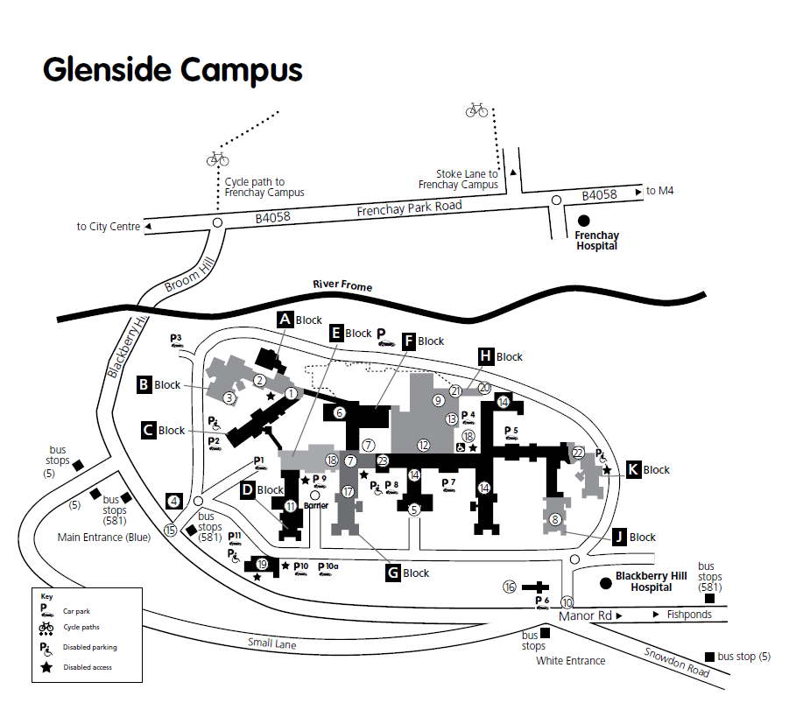
Main Entrance, Bus stops and route to IH16

