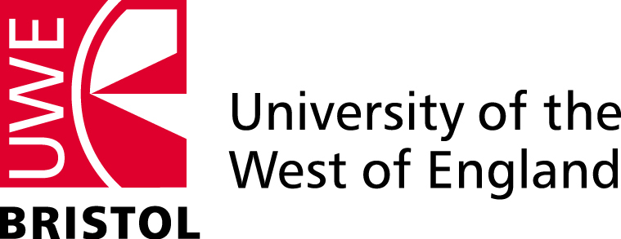 Bristol Leadership Centre
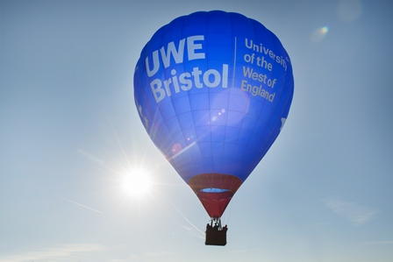 | “If your actions inspire others to dream more, learn more, do more, become more,  you are a leader.”  John Quincy Adams  Photo: The UWE balloon at the Bristol International Balloon Fiesta, August 2015

Bristol Leadership Centre supports the development of responsible and effective leadership practice and advances knowledge in the field of leadership studies. It is one of the largest university-based leadership centres in the country, delivering support and guidance for individuals and organisations grappling with the challenges of leadership and change in complex and uncertain times.

Welcome
Welcome to this first edition of Bristol Leadership Centre’s (BLC) newsletter. It is almost 12 months since BLC was launched and it’s been a busy year for our members.
Many of you will have been present at our launch in November 2014 and will recall our discussion about effective and responsible leadership being one of the most highly valued - yet elusive - processes within contemporary society. Recent crises in public and private sector organisations continue to demonstrate the benefits of good, and the perils of poor, leadership practice. Whilst there may be agreement about the need for better leadership, how this is developed, understood and sustained remains a topic of much debate.
The revelations about Volkswagen systematically misleading regulators and the public about carbon emissions and fuel efficiency; the rifts that continue to emerge within the Labour Party since the election of Jeremy Corbin as leader; and the ongoing migrant crisis in Europe – are all prime examples of the VUCA (volatile, uncertain, complex and ambiguous) world in which we live and implications for leaders, followers and society more generally.
BLC members continue to work closely with local, national and international organisations - researching, teaching and debating about responsible and effective leadership. Some examples of the projects we are currently undertaking and the impact we are having on policy and practice are included in this newsletter.
Also highlighted in this issue are some of the progressive leadership development programmes supported by BLC members such as the award-winning Team Entrepreneurship programme for undergraduate students looking to run their own business.
Our members are keen to engage with academic partners, organisations and businesses to advance practice and knowledge in the field of leadership studies and I would encourage you to make contact with us to find out more.
Professor Richard Bolden
Director of Bristol Leadership Centre
Richard.Bolden@uwe.ac.uk
Research Projects
The following projects are great examples of our research with local, national and international impact.
Bristol Golden Key Initiative
Golden Key is an eight-year £10 million Big Lottery funded partnership programme which aims to find new and sustainable ways of working with people with multiple complex needs, including homelessness, offending, drug and alcohol dependency and mental health issues.
BLC has been commissioned as the local evaluation partner and will be providing support and applied research throughout the duration of this initiative. The aims of the evaluation include:
- Identifying programme outcomes;
- Exploring mechanisms for change;
- Investigating social value and local economic impact;
- Exploring the role of psychologically informed working practices;
- Identifying lessons from pilot activity and
- Eliciting and sharing learning to inform future service design, commissioning and policy-making.
http://www.goldenkeybristol.org.uk
Systems Leadership: Local Vision
BLC has recently completed the evaluation of a national initiative looking at the transformation of public services and how shared leadership across organisations can help create solutions to complex social issues.
The Systems Leadership: Local Vision programme sets out to promote and facilitate radically different ways of leading transformation in public services to address challenges such as alcohol abuse, dementia, food poverty, and service integration. It is set amidst a government policy of austerity and a spotlight on public service outcomes.
The core aim of Local Vision is to develop shared leadership capability – a capacity and desire to collaborate across organisational boundaries and systems to generate solutions to ‘wicked’ issues. The programme was born out of the collective vision of the Leadership Centre (for Local Government) and the Systems Leadership Steering Group, comprising representatives from key agencies across government, the NHS, social care, public health, the voluntary sector and private sector.
In its evaluation, BLC has gathered evidence to understand the sustainability of service transformation at a local systems level through to end users and identifying emerging patterns to help inform understanding of effective systems leadership interventions.
http://www.localleadership.gov.uk/place/localvison
Preparing Vietnam for Malaria Elimination
Professor Peter Case has been collaborating with a medical team from the University of California, San Francisco (UCSF) on a Bill and Melinda Gates funded project to eliminate malaria in Vietnam. For the past eighteen months, Peter has been advising the principal investigator, Dr Colin Ohrt (COL ret. US Medical Corps), on program management and organisational issues relating to this ambitious project.
The key to eliminating malaria is use of real-time surveillance technology to identify malaria cases - most serious problems arise in remote forested regions - to ensure early interventions and disruption of parasite transmission. The disease is carried from one infected human to another by certain types of mosquito. There is also a range of prevention measures (e.g., taking anti-malaria drugs, sleeping under insecticide treated nets, and so on) that can be deployed, but there are often difficulties persuading villagers and forest workers to use them. Peter is using participative action research methods in workshops to draw on the expertise and knowledge of community and village health workers regarding how best to implement prevention and treatment technologies. The team from UCSF is also using pioneering new GPS and SMS technologies to set up ‘situation rooms’ in which malaria experts can advise less experienced health workers in the field on how to respond most effectively to malaria cases in real- time.
For further information please contact Peter.Case@uwe.ac.uk

Leadership Evaluation Collaboratory
Leadership activity in public, private and not-for-profit sectors increasingly focuses on the challenges of addressing complex, systemic problems that lie beyond the remit and capacity of a single group or organisation to address. Evaluating the impact of this kind of learning is especially challenging since it requires the ability to assess influences across institutional boundaries as well as the ability to consider how to unpick causal assumptions.
Building on our growing reputation for knowledge through action, BLC, along with clients in the health and social care sectors are collaborating to explore the challenges (and hopefully some solutions) in relation to evaluating leadership development and its impact. This exciting work is being seeded by the NHS Leadership Academies in the South West and Thames Valley and Wessex and builds on work with colleagues for other recent commissions in the evaluation of systems leadership.
To find out more please contact: Anita.Gulati@uwe.ac.uk

Leadership and Management Programmes
BLC members actively contribute to a wide range of accredited and unaccredited programmes for undergraduates, postgraduates and experienced managers. In this section we highlight some of our latest initiatives.
Business (Team Entrepreneurship)
UWE Bristol offers a ground-breaking, innovative and entrepreneurial BA (Hons) degree which gives undergraduate students the opportunity to set-up and run their own team company; to 'learn by doing' whilst gaining a broad-based business degree. Inspired by the pioneering Finnish 'Team Academy' approach, UWE has led the way in introducing the course to the UK.
Business (Team Entrepreneurship) students keep office hours, deliver and manage projects, attend meetings, manage budgets and build valuable contacts and networks. Training sessions with an experienced team coach and a series of professional workshops and personal development sessions ensure students have the knowledge and support they need to develop their entrepreneurial potential.
In September 2015 Dr Carol Jarvis and Jill Burnett of UWE were awarded joint first prize in the ECIE 2015 Teaching Innovation and Entrepreneurship Excellence Awards for their work on the Team Entrepreneurship programme.
For further information please visit: http://courses.uwe.ac.uk/N191/
Institute of Leadership Management
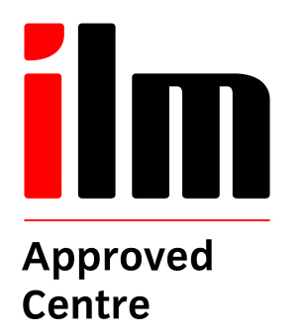
Bristol Business School is an approved ILM Centre offering a range of level 3 - 7 programmes in Leadership and Management and Coaching and Mentoring.
By studying at UWE, our students benefit from experienced academic staff with practitioner backgrounds that combine theory with practical implementation throughout the course. Students are offered the opportunity to combine their ILM study with achieving accreditation that can be used towards a selection of Master's level programmes.
We are running one of the first ILM level 7 Certificates in Coaching Supervision alongside our new post graduate, 30 credit coaching supervision module. We have also seen a marked increase in candidates for the ILM level 5 and 7 Coaching and Mentoring Certificates and are working alongside organisations such as Wessex Water to provide tailored versions of our programmes.
For further information please visit: http://tiny.cc/BristolILM or email fbl.cpd@uwe.ac.uk.

Professional Executive Development
Bristol Business School’s professional short courses are delivered by experienced academics and business consultants who combine their expertise with a practical focus.
Leading and Managing People is designed to give practitioners the skills and underpinning knowledge of leading and managing people. It encourages the use of theory to analyse issues, case studies and personal experiences. For example we are currently delivering a tailored programme to Avon and Wiltshire Mental Health Trust to enhance the knowledge and skills of 'front-line' team leaders across the Trust. We work closely with our clients to ensure that programmes meet organisational needs. Often this results in the generation of applied research. For example with AWP we are collaborating to explore the impact of coaching.
In response to a recent research project into barriers to growth for small and medium sized businesses, UWE Bristol has developed two exciting new programmes:
- SME Director Development Programme: a short, tailored and highly practical training programme for SME Directors based around five single day workshops spread over six months. The programme includes a business diagnostic session and a contribution to course fees may be available for companies registered with the Growth Accelerator scheme
- SME Graduate Accelerator: this course has been specifically designed for small and medium sized employers who take on graduates but don’t have an in-house graduate development programme. It provides a comprehensive training package to develop leadership, project management and finance skills to attract, retain and get the best from direct entry graduates, accelerating their progression into more senior roles. For graduates, particularly those who haven’t studied business at university, it provides comprehensive development package to accelerate early career progression and to gain a Diploma in Management and Leadership, which is the benchmark qualification for full Chartered Management Institute (CMI) membership and progression to Chartered Manager status.
The PED team are also piloting an exciting management exchange scheme with Avon and Somerset Police. The idea is for middle/senior managers to undertake a short and semi structured exchange to see the world through a different lens and reflect on their own leadership style and organisation. Longer term, it is hoped to expand this exchange to a number of different organisations from different sectors in the South West.
For more information please contact stephen.batty@uwe.ac.uk 0117 32 81640

Research Seminar Series
The BLC Research seminar series is an opportunity to hear about the latest developments in leadership research. Autumn seminars include:
Monday 19 October 2015 - 14.30 to 17.00
Double Seminar: Distributed Leadership in Education
- Moving beyond the distributed ‘turn’ in educational leadership - Dr Howard Youngs, Auckland University of Technology, New Zealand
- Does it matter? Is distributed leadership the first step or the wrong path for higher education leadership? - Professor Sandra Jones, RMIT University, Australia
Wednesday 28 October 2015 - 14.30 to 16.00
- Place-based leadership and the inclusive city: an international analysis - Professor Robin Hambleton, University of the West of England
Wednesday 11 November 2015 - 14.30 to 16.00
- A Dialogue on Autonomist Leadership and Eco-Leadership - Dr Simon Western, Analytic-Network Coaching Ltd
To find out more and to reserve a free space please visit: http://tiny.cc/BLCseminars
Bristol Distinguished Address Series
The Bristol Distinguished Address Series is delivered by the Bristol Business School in partnership with ACCA, Bristol City Council, Bristol Junior Chamber, Bristol Post, Business West, CBI, CMI, FSB, IoD, ICAEW and West of England LEP. It provides a unique opportunity to hear about the challenges, issues and decisions being made at the highest level of strategic leadership.
Forthcoming speakers include:
- Rt Hon Sir Richard Needham, Earl of Kilmorey
- Dennis Hogan, Managing Director, Compass Group UK & Ireland
- Sir Stephen Wall, Chair, Pro-EU Federal Trust
- Lord Bichard, Chair, National Audit Office
To find out more and reserve your place visit: http://www1.uwe.ac.uk/whatson/bristoldeaseries.aspx
Twitter: #BristolLectures @UWEEvents
Save the date
Wednesday 29 June 2016 – 18.00 to 20.30
Distinguished Professorial Address
Professor David Collinson, University of Lancaster
https://info.uwe.ac.uk/events/event.aspx?id=18092

Publications
Recent publications by BLC members include:
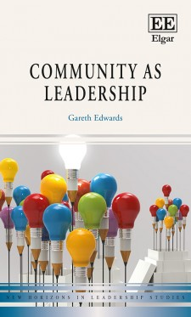 | Community as Leadership  Gareth Edwards*  Edward Elgar, 2015
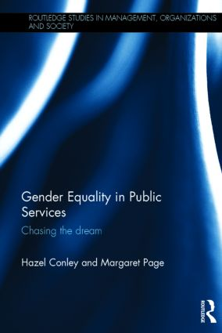 | Gender Equality in Public Services: Chasing the Dream  Hazel Conley and Margaret Page*  Routledge, 2015
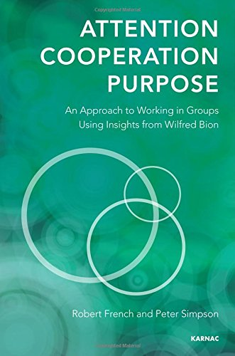 | Working in Groups: Attention, Cooperation and Purpose. Using Insights from Wilfred Bion  Robert French* and Peter Simpson*  Karnac, 2014
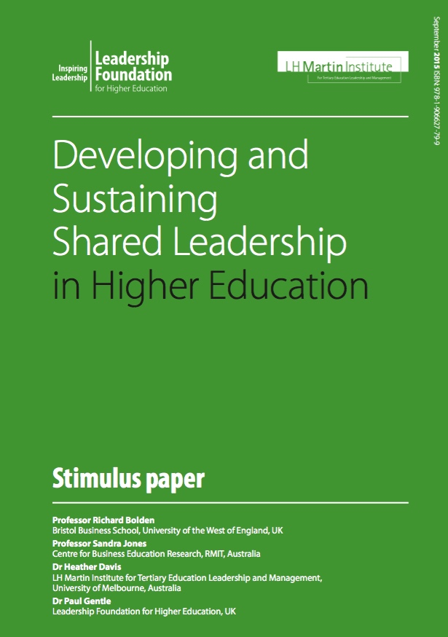 | Developing and Sustaining Shared Leadership in Higher Education  Richard Bolden*, Sandra Jones, Heather Davis and Paul Gentle  Leadership Foundation for HE, 2015
* These authors are members of BLC.
For further publications please visit: http://tiny.cc/BLCpublications

Contact
BLC@uwe.ac.uk
http://tiny.cc/BLC
@UWEleadership

