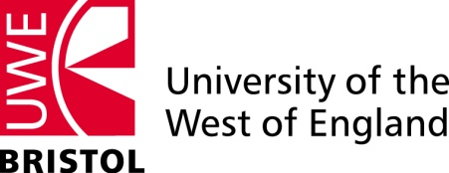 | 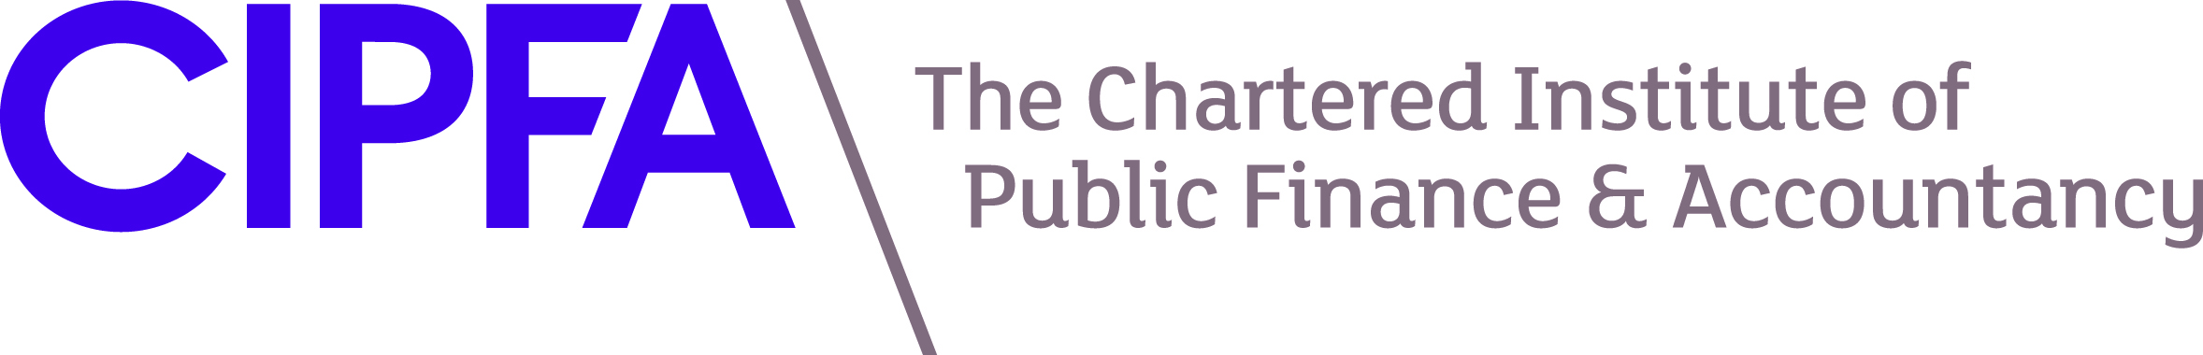

Public Sector Management and Accounting in a Time of Change
A BRICMAR conference in partnership with CIPFA

On 9 February 2011, in the Frome Room, UWE Event and Conference Centre, Frenchay Campus

Programme

11.45 am | Registration, coffee
12.00 noon | Introduction by  Martin Boddy and Robert Luther (Faculty of Business and Law, UWE)
12.10 pm | Keynote presentation by  Kevin Lavery, Chief Executive, Cornwall Council
12.45 pm | Lunch
1.30 pm | Howard Mellett (Cardiff Business School). The failure of accounting for the private finance initiative
2.00 | Alfred Lavadera (South Gloucestershire Council) Shared service provision in local government.
2.25 | Sheila Ellwood (Bristol University) Accounting magic: (dis)appearing hospitals
2.55 | Tobias Parker, Sustain Ltd. Sustainable management practices in public sector organisations.
3.20 | Tea
3.35 | Huw Thomas (Royal United Hospital Bath NHS Trust) Promoting efficiency through multifaceted performance measurement in the NHS.
4.05 | Jonathan Hale (Tribal Group) The performance challenge facing the NHS.
4.30 | Margaret Greenwood (University of Bath) The performance consequences of measurement reform in English NHS hospitals
5.00 pm | Closing remarks by Robert Luther

